**Integration of an Automated Approval and Financial Management System in the Metrobank STRONG Online Management System**

**A Thesis Proposal**

**Presented to the Faculty of the**

**Information and Communications Technology Program**

**STI College Ortigas-Cainta**

**In Partial Fulfilment**

**of the Requirements for the Degree**

**Bachelor of Science in Computer Science**

**Dann Ashley C. Aguilar**

**Kyle Edrian D. Bandola**

**Jericho V. Cañeso**

**Daniel A. Panturas**

**December 5, 2024**

**ENDORSEMENT FORM FOR PROPOSAL DEFENSE**

**TITLE OF RESEARCH: Enhancing Accountability Through the Integration of Financial Management in the Metrobank STRONG Online Management System**

**NAME OF PROPONENTS:** Dann Ashley C. Aguilar

Kyle Edrian D. Bandola

Jericho V. Cañeso

Daniel A. Panturas

In Partial Fulfilment of the Requirements

for the degree Bachelor of Science in Bachelor of Science in Computer Science

has been examined and is recommended for Proposal Defense.

**ENDORSED BY:**

Richard A. Santos

**Thesis Adviser**

**APPROVED FOR PROPOSAL DEFENSE:**

<Thesis Coordinator’s Given Name MI. Family Name>

**Thesis Coordinator**

**NOTED BY:**

Richard A. Santos

**Program Head**

# **APPROVAL SHEET**

This thesis proposal titled **Enhancing Accountability Through the Integration of Financial Management in the Metrobank STRONG Online Management System**, prepared and submitted by **Dann Ashley C. Aguilar; Kyle Edrian D. Bandola; Jericho V. Cañeso;** and **Daniel A. Panturas**, in partial fulfillment of the requirements for the degree of Bachelor of Science in **Computer Science**, has been examined and is recommended for acceptance and approval.

Richard Santos

**Thesis Adviser**

Accepted and approved by the Thesis Review Panel

in partial fulfillment of the requirements for the degree of

Bachelor of Science in Computer Science

|  |  |
| --- | --- |
|  |  |
| **Panel Member** | **Panel Member** |

**Lead Panelist**

**Noted:**

|  |  |
| --- | --- |
| Salvador T. Gascon Jr. | Richard A. Santos |
| **Thesis Coordinator** | **Program Head** |

**December 5, 2024**

# **TABLE OF CONTENTS**

|  |  |  |
| --- | --- | --- |
|  | | Page |
| Title Page | | i |
| Endorsement Form for Proposal Defense | | ii |
| Approval Sheet | | iii |
| Table of Contents | | iv |
| Introduction | | 1 |
|  | Background of the problem | 2 |
|  | Overview of the current state of technology | 4 |
|  | Objectives of the study | 9 |
|  | Scope and limitations of the study  Review of related literature/studies/systems | 11  13 |
| Methodology | | 19 |
|  | Hardware/Software | 27 |
|  | Calendar of Activities | 32 |
|  | Budgetary Estimate | 33 |
|  | Human Resources | 33 |
| References | | 39 |

**LIST OF FIGURES**

Figure Page

|  |  |  |
| --- | --- | --- |
| 1 | Figure 1: Agile Scrum Methodology | 20 |
| 2 | Figure 2. Proposed Data Flow Diagram of the System | 23 |
| 3 | Figure 3. Proposed System Flowchart | 24 |
| 4 | Figure 4. Proposed Data Flow Diagram of the System | 25 |
| 5 | Figure 5. Proposed Entity Relationship Diagram of the System. | 26 |

**LIST OF APPENDICES**

Appemdix Page

|  |  |  |
| --- | --- | --- |
| A | Interview and Requirements Gathering | 42 |
| B | Proposed Wireframe | 128 |
| C | Current Workflow Process | 131 |
|  |  |  |
|  |  |  |
|  |  |  |
|  |  |  |
|  |  |  |
|  |  |  |

**INTRODUCTION**

The Metrobank Foundation, Inc. (MBFI) is the corporate social responsibility arm of the Metrobank Group, supporting programs in education, visual arts, health, and excellence in key professions (Metrobank Foundation, 2024). STI Foundation, overseeing STI College branches across the Philippines, provides quality education, empowering students for academic and professional success (STI Holdings, 2023).

The Metrobank STRONG Scholarship Program offers financial support to STI students, covering tuition fees and allowances. Despite its success, challenges remain in managing document approval workflows and tracking allowances, resulting in inefficiencies and delays.

A financial management system streamlines tracking and reporting financial resources (Workday, 2020). In this case, the system will track allowances and incentives, automate approval processes, and provide analytics to assess how the scholarship funds are used and allocated, allowing for better decision-making through visualized data.

This study aims to develop a financial management and workflow approval module to be integrated into the Metrobank STRONG Online Management System, improving the efficiency and transparency of the scholarship program.

**Background of the problem**

Scholarship programs play a critical role in supporting higher education, promoting academic success, and fostering inclusivity. Corporate-backed initiatives, such as the Metrobank STRONG Scholarship Program, represent significant investments in human capital and societal growth. However, as the program expands, its financial and administrative processes have become increasingly challenging, exposing critical gaps in the current system.

The program’s financial management is hindered by disbursement delays and inefficiencies in communication. Scholars often receive their allowances later than scheduled, as evidenced by the delayed semestral allowance received on November 18, 2024. This delay stems from a fragmented approval process and poor communication workflows, which cause administrators to be unaware when tasks have been completed or are pending their review. Furthermore, the lack of centralized tracking methods makes it difficult to monitor payment schedules, disbursement history, and fund allocations, leading to delays in financial management (Workday, 2020).

These challenges highlight the need for an integrated financial management system within the Metrobank STRONG Online Management System. The absence of real-time updates and the disjointed nature of the current system hinder efficient decision-making and financial tracking. By automating workflows and centralizing financial data, these issues can be addressed, making the disbursement process more streamlined and transparent (Workday, 2020).

Studies like Odiyo et al. (2024), which examined similar disbursement delays in Kenya’s public education system, demonstrate the benefits of integrating automated tracking and monitoring systems. These systems not only reduce administrative burdens but also ensure timely and accurate fund distribution, improving financial security for recipients and enabling more effective program management (Accord Consulting, 2023).

By ensuring timely disbursements and improving fund tracking, the system will not only enhance operational efficiency but also support Metrobank’s commitment to developing the country’s future workforce by investing in scholars who can contribute to future organizational growth.

This study aims to address these gaps by developing a system that automates approval workflows, centralizes financial tracking, and provides real-time updates to both scholars and administrators. The proposed system will not only solve current inefficiencies but also set a precedent for similar scholarship programs by demonstrating how automation and integrated financial management can enhance both operational efficiency and accountability. The success of this model could inspire other programs to adopt similar approaches, fostering more transparent, efficient, and data-driven scholarship management systems across different sectors (Workday, 2020; Accord Consulting, 2023).

**General Problem**

The problem with Metrobank in their scholarship management is the lack of a complete financial management system. Which results in the struggle of managing scholarship disbursements, tracking budgets, and conducting financial analyses. As the program continues to grow, the demand for a modern and centralized approach in the process of financial management.

Specific Problems

1. Inefficiency in the financial disbursement approval workflow.

Scholars may experience delays in their financial disbursement and this can lead to financial strain, impact academic performance, and potentially harm the program's reputation among scholars. Metrobank STRONG program has a structured workflow of approval however it's not efficient due to number challenges they experience due to poor communication among multiple parties, lack of a centralized information source, and simultaneous processing of enrollment and allowance, causing delays and confusion.

1. Inefficient tracking and management of the scholarship grant.

The use of Microsoft Excel for tracking scholarship disbursements limits administrators’ efficiency due to its reliance on manual data entry and lack of automation, which increases the risk of delays and missed communications. Without real-time collaboration features, it is challenging for multiple users to access up-to-date information, leading to inconsistencies. In addition, the lack of the automated notification for timely reminder consumes the administrator time and risks miscommunication by composing and sending emails to various students. Additionally, Excel’s limited scalability and reporting capabilities make it difficult to track trends and adjust to a growing number of scholars. These constraints reduce productivity and hinder the program’s ability to support scholars effectively as it grows.

1. Inadequacy of data analysis in scholarship program’s ROI

The Metrobank STRONG Scholarship program currently has no means to measure the detailed success of their program. The program provides scholarships to deserving students with the goal of reducing talent acquisition costs, the absence of data analysis impacts the organization's ability so it is difficult to determine if it is effectively lowering hiring costs and producing skilled employees who can contribute meaningfully to the company’s success. Additionally, this lack of data-driven insights prevents the organization from making informed decisions about the program’s future whether to continue, adjust, or improve its implementation.

**Overview of the Current Technology**

According to Miss Vesah Garcia the current process of Metrobank STRONG Program spans in multiple stakeholders, including Metrobank HR, STI Foundation (STIF), Metrobank Foundation Inc. (MBFI), STI Education Service Group (ESG), and STI Finance. The process begins with Metrobank HR finalizing a list of scholars eligible for the allowance, which typically takes around three (3) weeks. Once finalized, HR sends the list to STIF and MBFI via an inter-office letter, a step that usually requires three (3) days. Upon receiving the list, STIF and MBFI confirm receipt within two (2) days (ideally one), and STIF informs the STI Branch Coordinators of the scholarship results within three (3) days. Coordinators then notify students via school email, aiming to include Metrobank STRONG, MBFI, and STIF in the communication. This notification step typically takes an additional two (2) days. Metrobank HR then submits a detailed semestral allowance request to STIF and MBFI, including the list of scholars, allowance amounts, and the breakdown per year level as specified in the Memorandum of Agreement (MOA). This process takes approximately one (1) week. Once received, STIF and MBFI acknowledge the details within two (2) days. STIF then prepares a comprehensive breakdown of allowances, which may include scholar counts by year level and total amounts, typically completed in one (1) week.

Next, STIF submits a Request for Payment (RFP) to STI ESG, a step that requires one (1) day. STI ESG processes this RFP and generates a billing statement for MBFI within two (2) days. MBFI, upon receiving and acknowledging the billing statement, initiates the payment process within three (3) days and deposits the allowance into the STI ESG account, a step that can take up to two (2) weeks. Once the deposit is confirmed, MBFI notifies STIF, which typically takes one day. STIF then acknowledges the deposit and submits a final RFP to STI Finance for disbursement to scholars, a step completed in one day. STI Finance then processes this RFP within one day and arranges the release of allowances, which takes approximately one week. After disbursement, STI Finance informs STIF within two days, which then prompts STI Finance to notify STI Holdings for final approval within another two days. Upon completion, STIF communicates the successful release to MBFI and the Metrobank STRONG Team within one day. Finally, the Metrobank STRONG Team sends a memo to scholars, instructing them to withdraw their allowances. This last step, including notifications to all stakeholders, typically takes two days.

According to Miss Mia Martha Valencia and Miss Vesah Garcia, throughout this complex process, the team heavily relies on Microsoft Excel to track schedules, monitor disbursements, and maintain scholar records. Ms. Ves expresses that searching for specific records and reports takes up from 3 hours if on a timeline and up to 5 hours if there are none. While Excel is a versatile tool, it poses significant limitations in this context. Retrieving historical data, analyzing trends, or generating consolidated reports requires tedious manual work. For instance, if a disbursement discrepancy arises, staff must comb through extensive spreadsheets to identify and resolve the issue, increasing the risk of human error and delays. See ***appendix C for current process workflow*** of the program

Moreover, the use of Excel provides no way to measure the broader success of the scholarship program. There are no tools to analyze whether the financial support positively impacts scholars’ academic performance, career success, or community contributions. Miss Vesah Garcia highlighted that Metrobank currently lacks the ability to evaluate return on investment (ROI) or assess how well the program aligns with the organization’s strategic objectives. As a result, the program operates reactively, focusing only on immediate disbursement needs without leveraging data to drive long-term improvements. The absence of modern technology limits Metrobank's ability to visualize the program's success or address inefficiencies. Imagine if Metrobank could access dashboards that display real-time data on allowance disbursements, scholar performance, and program outcomes. Such a system could not only streamline workflows but also provide actionable insights, enabling Metrobank to optimize its scholarship investments and strengthen its impact.

The current process demonstrates the need for an integrated financial management system equipped with data analytics. By transitioning from Excel to a modern platform, Metrobank could enhance accuracy, transparency, and efficiency while gaining valuable insights into the program’s long-term benefits for both scholars and the organization.

**Objectives of the study**

**General Objectives**

To design and develop a Web-Based integration of Financial Management System for the Metrobank STRONG Scholarship Program that streamlines the process of scholarship disbursements, automating notification, and improves financial analysis capabilities.

**Specific Objectives**

Specifically, the proposed study aims the following:

1. To design and develop a Workflow Approval Module that would reduce total processing time by 50%

The document workflow approval process will be automated via a web-based system, enabling the Metrobank STRONG Scholarship Program to handle approvals efficiently and avoid delays. The system will include an admin module where administrators can create, manage, and monitor approval workflows, including a centralized view of all pending workflows they have initiated. Approvers and administrators will have real-time visibility into approval stages and responsibilities, improving tracking and transparency. Customizable workflows will allow administrators to assign approvers, upload necessary documents, and submit files for approval. Automated notifications will keep stakeholders informed throughout the process, ensuring smooth operations and reduced administrative workload. The system will reduce the total time of processing from 12 weeks to 6 weeks.

1. To design and develop a Financial Disbursement System module and Tracking system for administrators that will reduce record keeping and data entry times to an instant.

This system will integrate financial management and tracking functionalities, allowing administrators to view and update disbursement schedules, track payment statuses, and manage data more efficiently in an automated, centralized platform. The system will automate key processes, eliminating manual data entry errors and delays associated with using Excel. Real-time notifications will alert administrators about upcoming disbursement deadlines and notify scholars about their payment schedules, improving communication and reducing the risk of missed deadlines. By providing real-time updates, scalable functionality, and timely alerts, the system will streamline the financial disbursement process and support the growing needs of the scholarship program, enhancing efficiency, accessibility, and reliability

1. To Design and Develop a Data Analytics ROI Evaluation System

The system will enable Metrobank STRONG program administrators to measure the success of the scholarship program by analyzing the relationship between the program’s costs and hiring cost, specifically focusing on the reduction of talent acquisition costs and the effectiveness of the program in producing skilled employees. This system will provide a dashboard containing various graphs and metrics to show whether the program is achieving its goal of reducing hiring costs while acquiring skilled employees. Modules such as Cost Comparison will be integrated, displaying bar or line graphs that track and compare the total costs of hiring scholars (including scholarship expenses) versus non-scholar candidates, accounting for recruitment, onboarding, and training expenses. Furthermore, the Data Visualization and Reporting module will generate an easy-to-understand dashboard that presents key metrics such as total costs, cost savings, and hiring outcomes. This module will allow Metrobank to visualize the financial impact of hiring scholars in real-time, offering insights into whether the program is effectively acquiring talent at a lower cost and whether any adjustments are necessary for future improvements.

**Scope and limitations of the study**

The development of the Financial Management System for the Metrobank STRONG Scholarship Program is designed to address critical issues in the current manual processes of scholarship disbursement, fund tracking, and financial analysis. This study focuses on creating a comprehensive and automated system that will streamline these processes, improve efficiency, and enhance accountability. By integrating this system into the existing Metrobank STRONG Online Management System, the study seeks to improve communication, reduce delays, and optimize financial management for both scholars and administrators.

**Approval Workflow Platform Module:**

* Create/Edit Document Approval: Enables the administrator to create/edit approval workflows within the Metrobank STRONG Online Management System.
* Dynamic Workflow Creation: Provides a flexible creation of custom approval workflows, allowing administrators to define sequence of approvers.
* Assigning Approver/s: Administrators would be able to assign specific approvers based on their roles and position.
* Document Uploading: The system supports different file formats, to ensure that uploaded files meet the specified criteria, such as file size limits (e.g. file size does not exceed to 400KB, in order to maintain system performance.
* File Format Support: Ensures that the system supports different file formats (e.g., PDF, DOCX, XLSX), ensuring compatibility and facilitating smooth document handling and approval process.
* Monitoring Created Approval: Provide a real-time overview of the progress of document approvals, to ensure transparency and efficient management of approval workflows
  + Progress Indicators and Status Tracking: Displays progress status (e.g. Pending, In Progress, Completed) to help administrators and reviewers to track the document approval stages.
  + Notification for status and reminders: Sends automated notifications and reminders to higher ups about pending approvals, and status changes.

**For Scholarship Administrators:** They can create workflows that support a wide variety of attached file formats, with a flexible sequence of approvers. Can view approval status and approval stage. They can get notified if a approval is completed **For Scholarship Staff:** Can receive and get notified of workflow approvals. Can accept and reject workflow approvals.

**Financial Disbursement Scheduling and Tracking Module:**

* Create/Edit Disbursement Schedule: Allows administrators to create and modify disbursement schedules for scholarship allowances, ensuring timely and organized payments.
* Calendar Schedule Monitoring: Provides an integrated calendar to all scheduled disbursements.
* History of Disbursement: Provides a complete view of all disbursement transactions, including details of records of payment dates, amounts, and recipients.
* Total Scholarship Cost: Displays the total cost of the scholarship program, categorized by different expenses types (tuition, allowances, incentives, other expenses)
* Reminders for approaching schedule: Automated reminders to notify administrators and scholars of upcoming disbursement dates.
* Integration of Google Calendar API:

**For Scholarship Administrators:** Can view history of disbursement transactions, and can view records and data entries of scholar information. Can create scheduling notifications and get notified of upcoming schedules.

**Scholar Disbursement Notification:**

* Web-based notification: Includes an alert system designed to inform scholars about the status of their scholarship disbursements. It provides key details such as the disbursement amount, scheduled date, payment method, and the current status (e.g., pending, approved, disbursed, delayed).

**For Scholars:** Can get notified of upcoming scholarship disbursement along with its status and key details.

**Data Analytics in Scholar Hiring:**

* Hire Conversion Rate: A dashboard that tracks the number of scholarship recipients hired by Metrobank compared to the total number of graduates. This would visually show how effective the program is in producing qualified hires.
* Cost Reduction Metrics: Visual graphs comparing the cost of external recruitment versus the cost of hiring scholarship recipients, showcasing the financial benefits of hiring directly from the program.

Metrics: Necessary data to use data analytics in scholar hiring:

* Total breakdown of semestral allowance (Incentives, allowance, enrolment)
* Total Active Scholar
* Total Active scholarship cost per batch,
* Talent Acquisition Cost (300k standard approximation of hiring cost per hire),

**For Scholarship Administrator:** Can view the relevant metrics for data analytics. Can view the data visualizations and the numbers of which data analysis is based upon.

### **Limitations of the study** This research faces several anticipated limitations related to its scope and, technical infrastructures. These constraints could affect the implementation and operation of the financial management and workflow approval modules within the Metrobank STRONG Online Management System. Below are the identified limitations:

* **Specific Context of Application:**

The system's design and recommendations are tailored exclusively to the Metrobank STRONG Scholarship Program. Generalizing its functionality to other scholarship programs or organizational structures may not be appropriate.

* **Lack of Predictive Analytics:**The system focuses on data visualization and basic analytics, not predictive analytics. As such, it cannot forecast trends or outcomes but only organizes and presents historical data.
* **Dependency on Stable Internet Access:**The system is intended to be web-based, requiring a reliable internet connection for both administrators and users. This reliance may limit functionality in regions with unstable internet connectivity.
* **Restricted Financial Scope:**The system does not manage the actual transfer of scholarship funds but serves as a notification and tracking tool. Consequently, any discrepancies or delays in fund transfers will fall outside its capabilities. The system is not designed to process electronic payments such as credit card transactions, debit cards, or mobile payment platforms like GCash.
* **Limited Integration with External Systems:**The scope of the study does not cover integration with third-party financial systems or platforms, which might limit its application for broader financial management tasks.
* **Subjective Analysis Beyond ROI Metrics:**While the system provides visualizations to assess scholarship ROI, it does not account for qualitative aspects such as scholars' personal growth or broader contributions, which may also reflect the program's success.

**Review of Related Literature/Study/System**

This chapter includes discussion on the relevant and supporting materials that will provide foundation of knowledge to the study. This gives insights on both research and conceptual literature as well as the rationale of the framework of the study.

1. **Local Literature/Study/System**

**A Data-Driven Approach in Predicting Scholarship Grants of a Local Government Unit in the Philippines Using Machine Learning  
Study**

Fajardo et al. (2023) highlight the inefficiencies of traditional scholarship management methods, particularly in handling the growing number of applicants and the increasing complexity of the selection process. As educational institutions face challenges such as biases in decision-making, lack of transparency, and difficulties in resource allocation, the study emphasizes the need for a more data-driven approach. The authors propose the use of analytics technology to streamline the scholarship allocation process, making it more efficient and equitable. The study aligns with the objectives of the Financial Management of the Metrobank STRONG Scholarship Program by offering insights into improving the transparency and efficiency of scholarship management, ensuring that resources are allocated to deserving candidates. By addressing the inefficiencies in traditional methods, this approach can inform the development of a more effective financial management system within the scholarship program.

**Disbursement Procedure Challenges of a Public Medical Institution in the Philippines**

Denoso, R. (2023) mines the challenges in disbursement procedures within a public medical institution in the Philippines, focusing on delays caused by bureaucratic structures and reliance on manual processes. It highlights how hierarchical approval systems, extensive documentation requirements, and complex regulatory protocols create bottlenecks in payment processing. These inefficiencies disrupt operations, strain supplier relationships, and hinder the hospital’s supply chain. Suppliers face delayed payments, negatively impacting their confidence and willingness to work with public institutions, which can reduce competition and cost-efficiency for the hospital. The study underscores the need for digital transformation, such as adopting e-payment systems, to improve efficiency, optimize procedures, and enhance supplier satisfaction. These insights are relevant to the Financial Management of the Metrobank STRONG Scholarship Program, particularly for its financial management module, as they highlight the importance of automated tracking, streamlined workflows, and enhanced transparency to ensure efficient and timely allowance distribution.

**DocTrack: A Dynamic Document Tracking System for the University of Northern Philippines**

Castro, F. (2022) system at the University of Northern Philippines improves document management and approval processes, similar to other studies that show how automation helps streamline workflows and reduce errors. The system was highly rated for its ease of use, which supports findings that user-friendly systems are more likely to be accepted. It also includes strong security features to protect data, which is a key aspect of any document management system. Additionally, by reducing paper and electricity usage, DocTrack helps the environment, as other studies have noted the environmental benefits of digital systems. For successful use, it is recommended that the system have proper training and support for users, as suggested by research on the importance of training in system adoption (Martin & Lee, 2022). Overall, DocTrack follows best practices from existing research, offering an efficient solution for managing documents in educational settings. This aligns with the objectives of the Metrobank STRONG Scholarship Program, it emphasizes the advantages of automating document management and approval workflow. By automating the document approval workflow it addresses challenges such as disbursement delays and manual processing errors.

**MaDox: A Digital Tracking and Scheduling System for the Dry Docking of Philippine-Flagged Vessels**

Ranoco et al., (2022) system addresses inefficiencies in drydocking schedules by unifying government agencies, shipowners, and shipyards in a digital platform. It automates processes, reduces scheduling conflicts, and integrates real-time updates and notifications to streamline operations. This centralized tracking and scheduling system concept will be applied to the financial disbursement module by creating an automated platform that integrates financial management and tracking functionalities. Administrators will efficiently manage schedules, payment statuses, and data while reducing errors associated with manual processes. Leveraging APIs like Google Calendar or Notification APIs, the system will provide real-time updates to administrators and scholars about payment deadlines, ensuring improved communication and timeliness while scaling to meet the scholarship program's growing needs. This approach aligns with the Metrobank STRONG Scholarship Program’s goal of automat

**UPD Scholars Get DOST Stipend After Two-Month Delay**

Abella, (2024) discussed how disbursement delays play a significant financial difficulty for many scholars. The recent two-month delay in the disbursement of stipends to Department of Science and Technology (DOST) scholars at UP Diliman highlights the financial hardships caused by inefficiencies in communication and processing between DOST-SEI.These delays have led scholars to face hardship that eventually affects their academics and personal responsibilities. Although the stipend disbursement was eventually resolved, this situation highlights the critical need for timely financial support for scholars to ensure their well-being and academic focus. The need for an automated system that not only streamlines financial processes but also provides real-time notifications to scholars, ensuring they are informed about disbursement schedules and potential delays. By incorporating automated, real-time alerts, the system can greatly improve communication, reduce uncertainty, and enhance the efficiency of stipend management. This aligns with the objective of automating the financial workflows and implementing real-time notifications to the Metrobank STRONG Scholarship Program, ensuring timely disbursements and enhancing the communication to prevent any financial strains and academic disturbances.

1. **Foreign Literature/Study/System**

**Development of a Real-time Document Approval System**

The article focuses on a real-time document approval system designed to streamline organizational workflows by automating sequential approval processes. With features like a user-friendly interface, digital submission and tracking, and real-time notifications, the system significantly enhances administrative efficiency. It minimizes delays and bottlenecks, improving transparency and fostering better coordination among stakeholders, particularly in distributed organizational setups. These functionalities are directly relevant to the Metrobank STRONG Scholarship Program Online Management System, particularly for its financial management module. By adopting the concept of sequential approval and incorporating interactive features such as real-time status updates and efficient workflow management, the proposed system aims to ensure a more traceable and error-free disbursement process. This alignment with best practices in automated systems enhances the accuracy and reliability of administrative operations for the scholarship program.

**The Importance of Tracking Corporate Scholarships and Best Practices for Management**

This article written by Uday (2024), highlights the importance of tracking corporate scholarships to measure their effectiveness and return on investment (ROI). It emphasizes how systematic tracking helps organizations assess the impact of scholarships on student success, including academic performance, graduation rates, and career outcomes. By maintaining accurate records and continuously monitoring scholarship recipients, organizations can ensure funds are used effectively and recipients receive necessary support. This aligns with the study's goal, which aims to develop an automated financial tracking and analytics system for the Metrobank STRONG Scholarship Program. By creating a tracker for the disbursement management system, it supports the need for efficient tracking, transparency, and effective allocation of scholarship funds.

**Why are Corporate Scholarships Important, and How to Manage them Expertly**

The SmartSelect (2024) article discusses the importance of managing corporate scholarships effectively, highlighting strategies like collecting quantitative data on academic performance, graduation rates, and career outcomes. Additionally, it emphasizes the need for assessing the return on investment (ROI) of scholarship programs. The article also explores how technology can streamline scholarship application processes. By using automated systems for application screening, document management, and communication, organizations can enhance efficiency, improve accessibility, and ensure fairness in the selection process. These strategies align with the objectives of the Financial Management of the Metrobank STRONG Scholarship Program, particularly in enhancing transparency, accessibility, and tracking the success of scholarship recipients.

**A Web Deployed Multi-Agent Based Approach for Student-Lecturer Appointment Scheduling in Institutions of Higher Learning** The study of Bokolo, A (2021), Web-based appointment scheduling systems are becoming popular because they help improve communication and efficiency, especially in schools. Wahab et al. (2021) created a system that helps students and teachers schedule appointments, making it easier to manage time and improve academic performance. The system was tested for usability, showing high satisfaction, reliability, and strong validity, meaning it works well. Other studies, like Jnr, also found that users rated the system highly for ease of use and fast scheduling. The system’s key features, such as easy navigation and quick appointment setting, were important for users. However, these studies focused only on universities in Malaysia, so the results might not apply everywhere. Future research could involve more people from different places and look at improving the system’s technology to make it even better. This aligns with the goal of the study for the Metrobank STRONG Scholarship Program, which aims to enhance the communication and efficiency through the integration of an automated financial management system. It will improve disbursement tracking and administrative workflows, ensuring timely communication with scholars and reducing processing delays.

**Role of Data Analytics in Business Decision Making**

Dr. Tiwari (2024) discusses how data analytics enhances decision-making by providing insights that guide organizations toward more informed and strategic choices. By applying advanced analytics, businesses can uncover hidden patterns and correlations in large datasets, offering clarity that may not be apparent through intuition alone. This approach can significantly benefit the Financial Management of the Metrobank STRONG Scholarship Program by facilitating better decision-making in scholarship fund allocation, identifying deserving candidates, and optimizing financial resources, ensuring that decisions are based on objective data-driven insights rather than assumptions.

**Synthesis of Related Literature, Studies, and System**

The studies reviewed highlight the importance of technology and structured approaches in improving financial management systems for scholarship programs. Locally, the transition from manual scholarship management to automated systems is exemplified in Fajardo et al. (2023), who highlight improvements in transparency, equity, and resource allocation through analytics-driven solutions. Similarly, Denoso et al. (2023) and Castro et al. (2022) underscore the significance of digital transformation in addressing inefficiencies in disbursement processes, aligning with the Metrobank STRONG Scholarship Program’s goal to automate workflows and enhance administrative efficiency. Also, Ranoco et al. (2022) and Abella (2024) advocate for real-time updates and notifications as pivotal features for improving communication, reducing delays, and ensuring timely disbursements to scholars.

In terms of data-driven decision-making, Dr. Tiwari (2024) highlights the value of data analytics in optimizing resource allocation and identifying deserving beneficiaries, which aligns with the program’s aim of leveraging analytics for efficient fund management. Foreign studies, such as those by Cherckesova et al. (2021), reinforce the advantages of sequential approval systems and user-friendly interfaces for improving transparency and minimizing errors in financial workflows. Uday et al. (2024) and SmartSelect (2024) extend this perspective by emphasizing systematic tracking and the importance of ROI analysis in managing corporate scholarships, providing a structured approach to monitoring scholar performance and program effectiveness.

Over and above that, Bokolo et al. (2021) and other foreign studies advocate for the adoption of web-based systems to enhance communication and administrative processes, demonstrating that user-centric designs improve usability and satisfaction. These findings resonate with the program’s objectives to integrate real-time tracking, automated notifications, and streamlined approval processes to better support scholars and administrators.

In summary, this synthesis suggests that combining automation, data analytics, and user-friendly designs with efficient communication mechanisms can significantly enhance scholarship management systems. By integrating these elements, the Metrobank STRONG Scholarship Program can ensure equitable, transparent, and timely financial disbursement processes while effectively scaling to meet growing demands.

**METHODOLOGY**

**Project Design**

In developing the Financial Management System with Automated Approval Workflow for Metrobank STRONG Program Online Management System the developer gathered necessary data through conducting interviews with the key personnel and observed the current system of the scholarship program. The developer plans to use the Agile Scrum Methodology. It has an iterative nature that enables frequent feedback and continuous improvement throughout the development process when building the components.

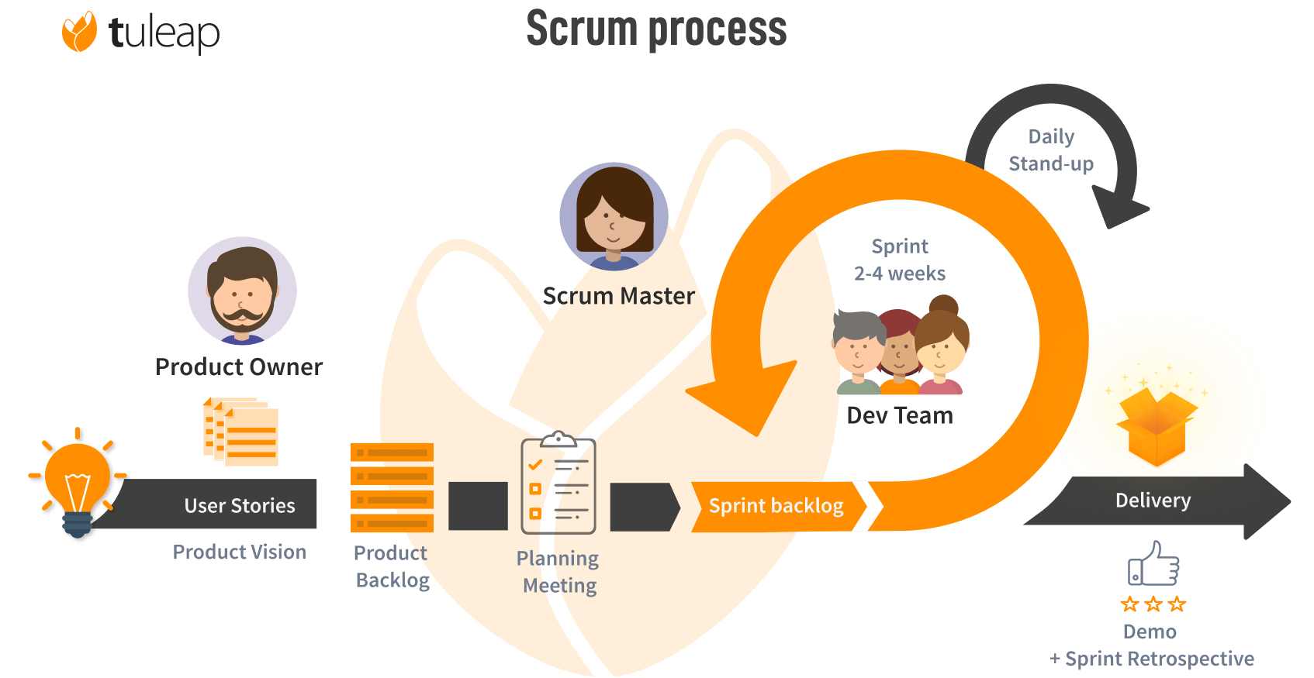

**Figure 1. Agile Scrum Development Methodology**

**Initiation Phase**

In the initiation phase, the team creates the project's vision by outlining a roadmap to the main objectives, goals and deliverables. The team identifies the stakeholders, and each member is assigned to each role to determine epics to form the project backlog. Information is required to know these project backlogs that’s why the team conducts an interview in Microsoft Teams with Miss Valencia, a Representative of Metrobank STRONG program and client of the system under study, and several questions are asked in which Miss Valencia answers. At the same time the process of the current system is given in which some observations are made by the developers. The developer also gathered information regarding the same system features from the internet, reading various related published articles, studies, and the same features that the other software product has. Gathered information was then analyzed in order to identify the main problems the current system is facing. Each member of the team then creates a product backlog list that contains features based on the information gathered. To ensure the project vision and client needs are captured, these formats are used for the product epic, “As a/the [user role], I want to [product capability] so that [user benefit].”

**Planning and Estimates Phase**

In the planning and estimates phase, this is where the product epic would be completed with several actions called user stories. User stories are formatted in the same way product epics are formatted and they’re quicker to implement. Proponents create user products to basically break the product epics into lightweight tasks to make them more manageable. In the initiation phase, product owners usually identify the user stories but the team can identify it with coordination in the product owner. The team then planned the iterative development by organizing the scrum sprints with product backlog as features to develop. The team will do sprint planning and identify the sprint backlog or user stories they like to work on based on its level of priority. Using project management software such as Jira will manage the product backlogs and task assignment towards each member.

**Implementation Phase**

In the implementation phase, development takes place by executing the task and activities to accomplish the goal of the product and complete the project deliverables. The team will conduct a meeting scheduling Monday, Wednesday, and Friday for stand-up meetings. It was a quick and regular meeting to know what tasks the member has done, what he plans to work on next, and what issues he faced. In addition to that, the team will use burndown charts that illustrate how the team progressed, this is where the team compares how much they should accomplish compared to the tasks they have done. With this, the team could ensure that communication is constant with regards to the product, it ensures that product is progressing as planned.

**Review and Retrospective Phase**

In the review and retrospective phase, this is where proponents and stakeholders create meetings to evaluate what was successful, what could be improved, and what’s the next step to take by gathering the feedback of customer and team insights.The team will conduct sprint review in order to assess the progress of the project, At the end of each sprint, the team demonstrates the system to stakeholders, such as Miss Valencia, the Metrobank STRONG representative, showcasing completed functionalities like financial disbursement workflows and notification integrations. Feedback on usability, functionality, and alignment with objectives is gathered and documented, with suggested improvements added to the product backlog for future prioritization. Simultaneously, the team reflects on their performance during a retrospective, discussing what went well, challenges encountered, and areas for improvement. By combining product evaluation with process optimization, this phase ensures the system evolves effectively while enhancing the team's efficiency.

**Release Phase**

In the release phase, proponents will be focusing on preparing and delivering the final project deliverables to stakeholders, such as Miss Valencia and the Metrobank STRONG team. This phase ensures that the system meets all functional and quality requirements, including financial disbursement workflows, scholar profile management, and notification integrations. Prior to deployment, the team performs final testing, configures servers and databases, and ensures all security protocols are in place. Training sessions are conducted to familiarize end-users with the system, ensuring a smooth handover. After deployment, continuous support and monitoring are provided to address any issues. A project retrospective is also conducted at this stage to reflect on the entire development cycle, identifying successes and areas for improvement, ensuring valuable lessons for future projects.

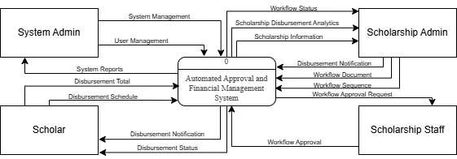

**Figure 2. Proposed Data Flow Diagram of the System**

Figure 3 illustrates the context diagram of an Automated Approval and Financial Management System. This diagram depicts the entities involved in the system and their interactions with it. The System Admin, Scholar, Scholarship Staff, and Scholarship Admin are the primary entities that interact with the system. The System Admin manages system-level functions such as system management and report generation. Scholars interact with the system to receive disbursement notifications and track their disbursement status. The Scholarship Staff handles workflow approval requests and processes disbursements. The Scholarship Admin oversees the system's workflow, analytics, and information related to scholarships. The Automated Approval and Financial Management System acts as a central hub, facilitating the flow of data and processes among these entities.

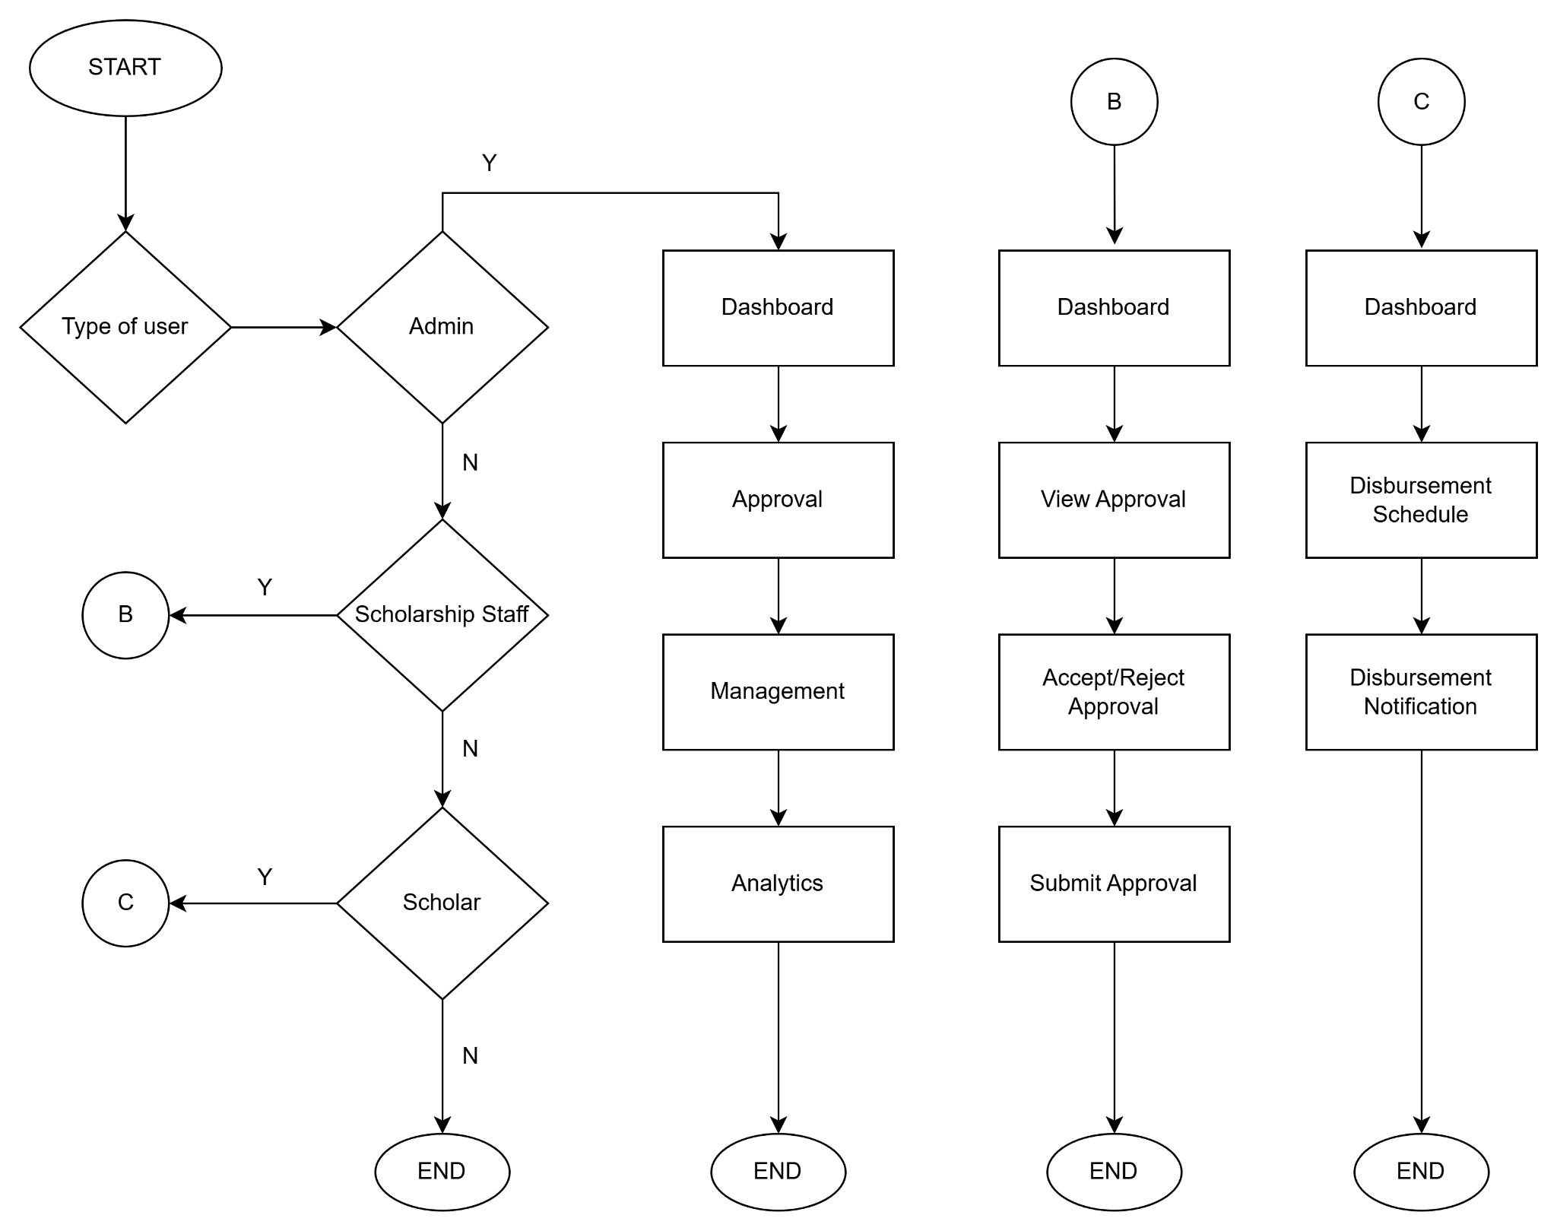

**Figure 3. Proposed System Flowchart**

Figure 2 shows the logical flow of major events in the system, it caters from time when the user will use the system. The system is tailored to different user types: Admin, Scholarship Staff, and Scholar. Upon accessing the system, the users are directed through distinct workflows based on their role. Admin users are navigated to the main dashboard, which provides access to modules, including the Approval module, which will have 3 different flows depending on the user type (Admin, Scholarship Staff, Scholar). Admin users will be directed to the main dashboard, where there he could see the approval module, management module, and analytics module. Scholarship staff would also be directed to the dashboard that has a view approval module, in this module the user would be able to see the list of all the pending documents that needs to be approved, after that they can either accept/reject approval, and if finished submit approval. Scholars would also be directed to the dashboard and can see the disbursement schedule, here will also display the status of the disbursement, and disbursement notifications.



**Figure 4. Proposed Data Flow Diagram of the System**

Figure 3 illustrates the context diagram of an Automated Approval and Financial Management System. This diagram depicts the entities involved in the system and their interactions with it. The System Admin, Scholar, Scholarship Staff, and Scholarship Admin are the primary entities that interact with the system. The System Admin manages system-level functions such as system management and report generation. Scholars interact with the system to receive disbursement notifications and track their disbursement status. The Scholarship Staff handles workflow approval requests and processes disbursements. The Scholarship Admin oversees the system's workflow, analytics, and information related to scholarships. The Automated Approval and Financial Management System acts as a central hub, facilitating the flow of data and processes among these entities.

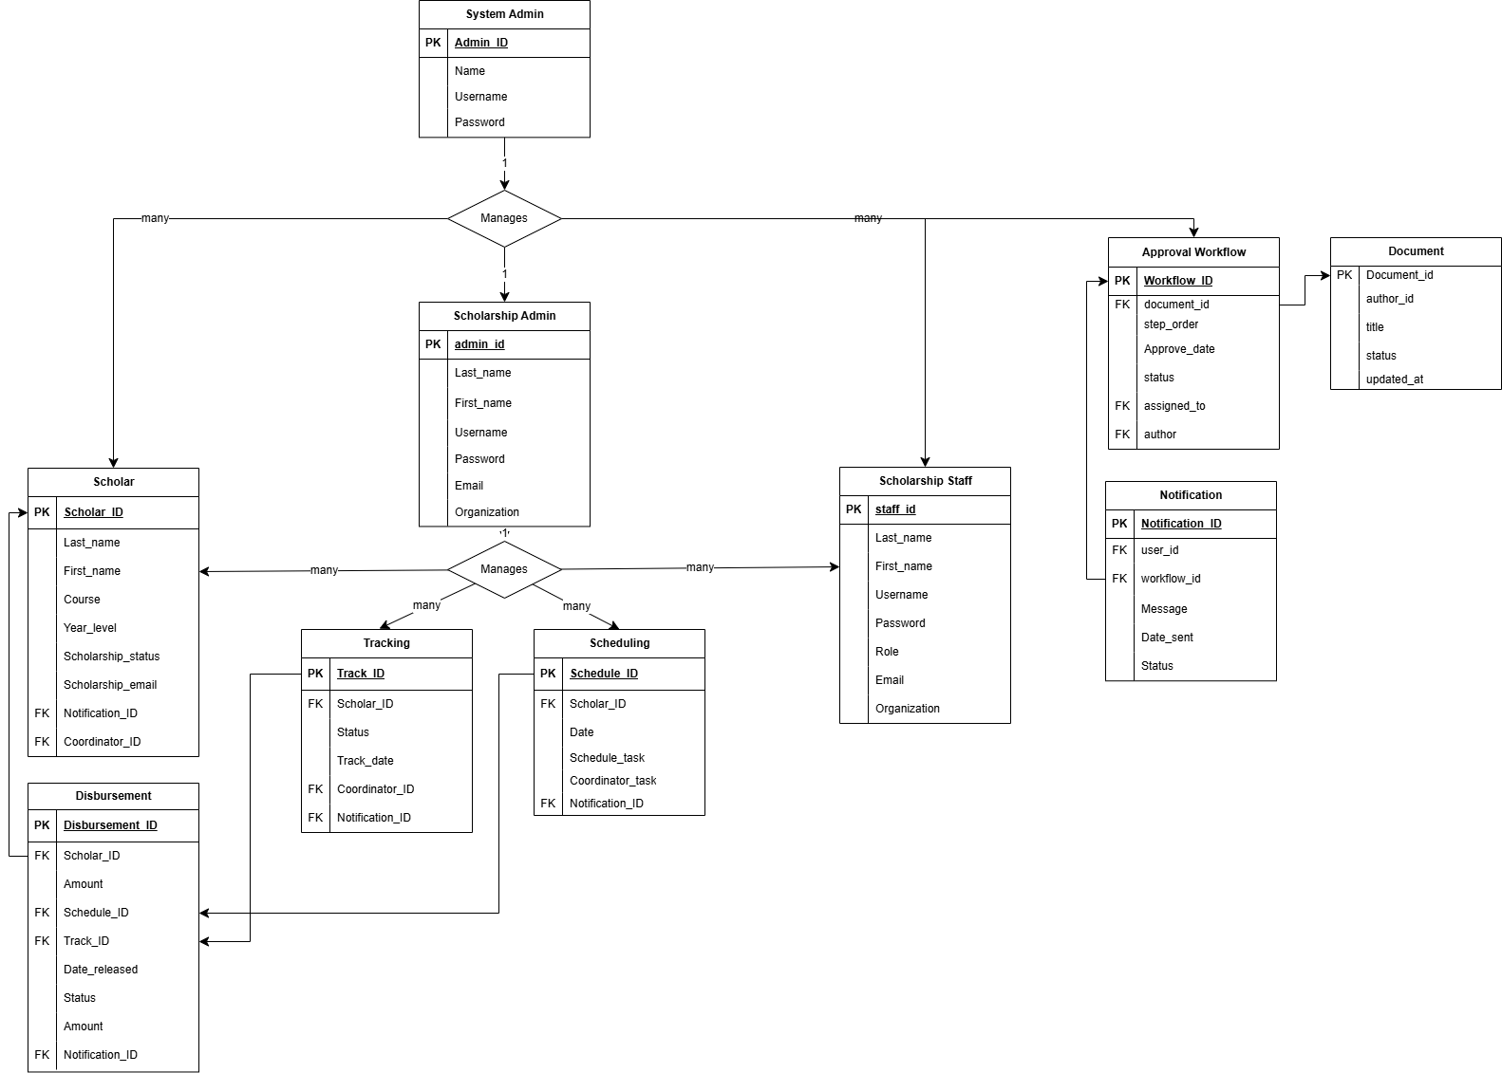**Figure 5. Proposed Entity Relationship Diagram of the System.**

An Entity-Relationship Diagram (ERD) is a visual representation of the relationships between entities in a database system. It provides a structured way to organize and understand the data requirements of a system, showing entities (data objects), their attributes, and the relationships that connect them. ERDs are essential tools in database design, offering a clear blueprint of how data flows and interacts within a system.

The ERD for the Metrobank STRONG Online Financial Management System outlines the roles and relationships between entities to support scholarship management. The System Admin oversees the platform, ensuring smooth operations while managing the Scholarship Admin, who handles scholars and their financial and program data. Scholars are tracked, scheduled, and monitored via the Tracking, Scheduling, and Disbursement entities, ensuring their allowances are managed effectively. The Approval Workflow automates document validation, linking Scholarship Staff to specific tasks. Notifications streamline communication across users, enabling timely updates on approvals, schedules, and disbursements. This structure enhances administrative efficiency, data tracking, and accountability.

**Hardware & Software Requirements**

**Hardware Requirements**

Here are the basic hardware specifications that proponents will need to develop the Automated Approval and Financial Management System:

1. **Computer Systems:** Desktop or Laptop with at least 8GB RAM and an Intel Core i5 or Ryzen 5 processor or equivalent with Windows 10 64bit or later. .
2. **Storage Space:** Minimum 256GB SSD for storing project files and tools.
3. **Display Monitor:** Simple single display monitor.
4. **Internet Connectivity:** Stable high-speed internet connection of at least 50MBPS.
5. **Backup Solutions:** Cloud-based backup services will be utilized

**Software Requirements**

**Integrated Development Environment (IDE) - Visual Studio Code**

Visual Code Studio is a robust and flexible integrated development environment (IDE) essential for both coding and development. Its wide range of plugins, syntax highlighting, and debugging tools enhance the coding experience for both frontend and backend projects, promoting efficiency and high-quality code.

**Programming Languages: (HTML, CSS, JavaScript)**

HTML is the standard language used to create the structure and content of web pages. It defines elements such as headings, paragraphs, links, images, and other multimedia content on a webpage. Basically, the backbone of web content, providing the foundation for everything seen in a browser.

CSS is a stylesheet language used to control the presentation and layout of the HTML elements. It can define the colors, fonts, spacing, and positioning of elements on a webpage. It helps in making web pages visually appealing and responsive, adapting the layout to different screen sizes.  
JavaScript is a programming language that enables interactive features and dynamic behavior on web pages. It allows developers to create responsive elements like form validation, animations, and event handling. It manipulates the HTML and CSS, providing a more engaging and interactive user experience.

**Frontend Framework:** (**React.js with Vite, Shad CN UI, Tailwind CSS)**

Using front-end frameworks such as React.js enables the creation of responsive user interfaces with ease. These frameworks streamline UI development, simplify component management, and provide a seamless user experience. When combined with tools like Vite, Shad CN UI, and Tailwind CSS, React.js further enhances the development workflow, leading to improved efficiency and a higher-quality final product.

Vite is a modern, fast build tool and development server that significantly speeds up the development process. It provides features like hot module replacement (HMR) and fast JavaScript and CSS compilation, which makes it an excellent choice for React projects. Vite is highly optimized for modern web development workflows and supports both development and production builds efficiently.

Shac CN UI is a set of pre-designed, accessible, and customizable UI components built with React.js. It provides library components, such as buttons, modals, and input fields, that follow modern design principles. Shad CN UI is built to be flexible and easy to integrate into React projects, allowing a quick building of a stylish and user-friendly interface.

Tailwind CSS is a utility-first CSS framework that provides low-level utility classes to build custom designs without writing a lot of custom CSS. Instead of designing styles in traditional CSS files, it can apply pre-built classes directly to HTML elements. It promotes a faster, more maintainable way of designing responsive and scalable web interfaces.

**Backend Frameworks: (Node JS & Express.js)**

Node.js is a powerful runtime environment that allows JavaScript to be run on the server side. Built on Chrome’s V8 JavaScript engine, Node.js enables developers to use JavaScript for both frontend and backend development, creating a unified development experience, mostly ideal for building fast, scalable applications that handles a large number of concurrent connections efficiently.

Express.js a minimalist web framework built for Node.js that simplifies the process of building backend applications. It provides a set of robust features to handle routing, handling requests, making it a popular choice for developing scalable and performant web applications.

**Database: (PostgreSQL)**

PostgreSQL a powerful, open-source relational database management system (RDBMS). The system will utilize PostgreSQL for storing and managing scholarship related data.

**Version Control System: (Git and GitHub)**

Git, along with GitHub, facilitates version control, collaboration, and efficient code management. It enables developers to track changes, manage branches, and maintain a smooth and organized development process.

**Testing and Debugging Tools: (Postman, Chrome DevTools)**

Postman and Chrome DevTools are essential tools for testing and debugging. Postman allows developers to test APIs by sending requests and analyzing responses, while Chrome DevTools provides powerful features for inspecting and debugging web applications, such as monitoring network activity, identifying performance issues, and debugging JavaScript.

**Project Management Tools: (Jira and MS Teams)**

Jira along with MS Teams, streamline project management by tracking tasks, organizing workflows, enabling seamless team collaboration through communication and file sharing.

**Deployment Platforms: (Vercel and Heroku)**

Deployment platforms like Vercel handle the hosting and deployment of the frontend, while Heroku manages the backend of the Financial Management System, ensuring both accessibility and scalability.

**APIs: (Google Calendar API, RESTful API)**

The system will integrate the Google Calendar API to automate and manage the scheduling of disbursements, reminders, and important events related to the Metrobank STRONG Scholarship Program. This integration will enable real-time synchronization of disbursement dates, deadlines, and notifications, providing administrators and scholars with timely updates. The use of Google Calendar's functionalities ensures seamless coordination, eliminating scheduling conflicts and enhancing communication across stakeholders. By leveraging this API, the system will streamline the financial management process, ensuring that both administrators and scholars are informed about critical events in real-time.

The system will also utilize RESTful APIs to enable smooth communication between various components of the Metrobank STRONG Scholarship Program. RESTful APIs will facilitate the integration of different services, allowing for seamless data exchange between the financial management system, notification modules, and other systems. This will enhance the overall functionality of the application, providing a flexible, scalable solution that supports automated workflows, real-time data updates, and efficient management of scholarship disbursements

## **Calendar of Activities**

|  |  |  |  |  |  |  |  |  |  |  |  |  |  |  |  |  |
| --- | --- | --- | --- | --- | --- | --- | --- | --- | --- | --- | --- | --- | --- | --- | --- | --- |
| YEAR | 2024 | | | | | | | | | | | | | | | |
| MONTH | SEPTEMBER | | | | OCTOBER | | | | NOVEMBER | | | | DECEMBER | | | |
| ACTIVITY |
| WEEK | 1 | 2 | 3 | 4 | 1 | 2 | 3 | 4 | 1 | 2 | 3 | 4 | 1 | 2 | 3 | 4 |
| Planning |  |  |  |  |  |  |  |  |  |  |  |  |  |  |  |  |
| Requirements Gathering |  |  |  |  |  |  |  |  |  |  |  |  |  |  |  |  |
| Chapter 1 |  |  |  |  |  |  |  |  |  |  |  |  |  |  |  |  |
| Chapter 2 |  |  |  |  |  |  |  |  |  |  |  |  |  |  |  |  |
| Chapter 3 |  |  |  |  |  |  |  |  |  |  |  |  |  |  |  |  |

**Table 1. *Figure 1:***

## LEGEND

Ongoing :

|  |
| --- |
|  |

Completed :

|  |
| --- |
|  |

**Budgetary Estimate**

|  |  |  |
| --- | --- | --- |
| Quantity | Specifics | Approximate Cost |
| 1 | Vercel for front-end Heroku for back-end | 6 months = ₱3,240.00 |
| 1 | Canon G1010 ink | 600 |
| 3 | White Folder | 13 |
| 3 | Paper Clip | 20 |

## Human Resources

The following pages contain the curriculum vitae of the researchers and the Adviser’s Acceptance Form.

Curriculum Vitae of

DANN ASHLEY C. AGUILAR

**626 JM Basa St. Libid, Binangonan, Rizal**

**dannashaguilar@gmail.com | aguilar.286826@ortigas-cainta.sti.edu.ph**

**09083142939**

EDUCATIONAL BACKGROUND

|  |  |  |
| --- | --- | --- |
| Level | Inclusive Dates | Name of school/ Institution |
| Tertiary | 2022-Present | STI College Ortigas-Cainta |
| Vocational/Technical | N/A | N/A |
| High School | 2014-2020 | Binangonan Catholic College |
| Elementary | 2008-2014 | Binangonan Elementary School |

PROFESSIONAL OR VOLUNTEER EXPERIENCE

|  |  |  |
| --- | --- | --- |
| Inclusive Dates | Nature of Experience/  Job Title | Name and Address of Company or Organization |
| Feb -Mar 2020 | Administrative Office Intern | TESDA Rizal Training Center – Binangonan. |

**Listed in reverse chronological order (most recent first).**

AFFILIATIONS

|  |  |  |
| --- | --- | --- |
| Inclusive Dates | Name of Organization | Position |
| N/A | N/A | N/A |

**Listed in reverse chronological order (most recent first).**

SKILLS

|  |  |  |
| --- | --- | --- |
| SKILLS | Level of Competency | Date Acquired |
| Java Programming | Intermediate | 2022 |
| Python Programming | Intermediate | 2022 |
| Web Programming | Beginner | 2022 |

TRAININGS, SEMINARS OR WORKSHOP ATTENDED

|  |  |
| --- | --- |
| Inclusive Dates | Title of Training, Seminar or Workshop |
| November 2024 | Huawei Talent- Overview of AI |
|  |  |

**Listed in reverse chronological order (most recent first).**

Curriculum Vitae of

KYLE EDRIAN D. BANDOLA

**Floodway Exodus, Blk 22 Lot 1, Matthew Street, Cainta Rizal**

**kylebandola30@gmail.com | bandola.297442@ortigas-cainta.sti.edu.ph**

**09682300505**

EDUCATIONAL BACKGROUND

|  |  |  |
| --- | --- | --- |
| Level | Inclusive Dates | Name of school/ Institution |
| Tertiary | 2022-Present | STI College Ortigas-Cainta |
| Vocational/Technical | N/A | N/A |
| Senior High School | 2020-2022 | STI College Ortigas Cainta |
| High School | 2016-2020 | Christ The King College of Angono |
| Elementary | 2010-2016 | Cainta Elementary School |

PROFESSIONAL OR VOLUNTEER EXPERIENCE

|  |  |  |
| --- | --- | --- |
| Inclusive Dates | Nature of Experience/  Job Title | Name and Address of Company or Organization |
| N/A | N/A | N/A |

**Listed in reverse chronological order (most recent first).**

AFFILIATIONS

|  |  |  |
| --- | --- | --- |
| Inclusive Dates | Name of Organization | Position |
| 2023-2024 | Alpha: Alliance of Leading Programmers through Heuristic Adaptation | Multimedia |

**Listed in reverse chronological order (most recent first).**

SKILLS

|  |  |  |
| --- | --- | --- |
| SKILLS | Level of Competency | Date Acquired |
| Web Programming | Intermediate | 2019 |
| Java Programming | Intermediate | 2022 |
| Python Programming | Beginner | 2023 |
| Javascript Programming | Intermediate | 2023 |
| SQL | Intermediate | 2023 |
| PHP | Intermediate | 2024 |

TRAININGS, SEMINARS OR WORKSHOP ATTENDED

|  |  |
| --- | --- |
| Inclusive Dates | Title of Training, Seminar or Workshop |
| July 2023 | Java Oracle Award |
| November 2024 | Huawei Talent- Overview of AI |
|  |  |

**Listed in reverse chronological order (most recent first).**

DANIEL A. PANTURAS

**Floodway Exodus, Blk 8 Riverside Taytay RIzal**

**panturasd@gmail.com**

**09750548224**

EDUCATIONAL BACKGROUND

|  |  |  |
| --- | --- | --- |
| Level | Inclusive Dates | Name of school/ Institution |
| Tertiary | 2022-Present | STI College Ortigas-Cainta |
| Vocational/Technical  Senior High School | N/A  2020-2022 | N/A |
| High School | 2016-2020 | Christ The King College of Angono |
| Elementary | 2010-2016 | Exodus Elementary School |

PROFESSIONAL OR VOLUNTEER EXPERIENCE

|  |  |  |
| --- | --- | --- |
| Inclusive Dates | Nature of Experience/  Job Title | Name and Address of Company or Organization |
| N/A | N/A | N/A |

**Listed in reverse chronological order (most recent first).**

AFFILIATIONS

|  |  |  |
| --- | --- | --- |
| Inclusive Dates | Name of Organization | Position |
| 2023-Present | ALPHA | Front End-Dev |

**Listed in reverse chronological order (most recent first).**

SKILLS

|  |  |  |
| --- | --- | --- |
| SKILLS | Level of Competency | Date Acquired |
| Java Programming | Intermediate | 2021 |
| Python Programming | Beginner | 2022 |
| Web Programming  SQL | Intermediate  Intermediate | 2022  2022 |

TRAININGS, SEMINARS OR WORKSHOP ATTENDED

|  |  |
| --- | --- |
| Inclusive Dates | Title of Training, Seminar or Workshop |
| November 2024 | Huawei Talent- Overview of AI |
|  |  |

**Listed in reverse chronological order (most recent first).**

Curriculum Vitae of

Jericho V. Cañeso

**Blk.11, Lot 46, Rd. 5, Arveemar Homes Subd, Angono, Rizal**

**jericho.caneso13@gmail.com | caneso.307787@ortigas-cainta.sti.edu.ph**

**09361854727 | 09937499160**

EDUCATIONAL BACKGROUND

|  |  |  |
| --- | --- | --- |
| Level | Inclusive Dates | Name of school/ Institution |
| Tertiary | 2022-Present | STI College Ortigas-Cainta |
| Senior High School | 2020-2022 | Trent Information First Technical Career Institute, Inc. |
| High School | 2016-2020 | Christ the King College of Angono, Inc. |
| Elementary | 2010-2016 | Christ the King College of Angono, Inc |

PROFESSIONAL OR VOLUNTEER EXPERIENCE

|  |  |  |
| --- | --- | --- |
| Inclusive Dates | Nature of Experience/  Job Title | Name and Address of Company or Organization |
| N/A | N/A | N/A. |

**Listed in reverse chronological order (most recent first).**

AFFILIATIONS

|  |  |  |
| --- | --- | --- |
| Inclusive Dates | Name of Organization | Position |
| N/A | N/A | N/A |

**Listed in reverse chronological order (most recent first).**

SKILLS

|  |  |  |
| --- | --- | --- |
| SKILLS | Level of Competency | Date Acquired |
| Java | Intermediate | 2022 |
| Python | Intermediate | 2022 |
| Web Development | Intermediate | 2022 |

TRAININGS, SEMINARS OR WORKSHOP ATTENDED

|  |  |
| --- | --- |
| Inclusive Dates | Title of Training, Seminar or Workshop |
| November 2024 | Huawei Talent- Overview of AI |
|  |  |

**Listed in reverse chronological order (most recent first).**

**REFERENCES**

Accord Consulting. (2024). The importance of integrated financial solutions. *Accord Consulting*. Retrieved from<https://www.accord-consulting.com/news/article/importance-of-integrated-financial-solutions>

Bendre, V., & Thool, R. (2023). State-of-the-art of artificial intelligence and big data analytics reviews in five different domains. *MDPI*. Retrieved from<https://doi.org/10.3390/su15054026>

Cherckesova, L., Boldyrikhin, N., Revyakina, E., Safaryan, O., & Yengibaryan, I. (2021). Development of a real-time document approval system. *E3S Web of Conferences, 273*, 08047. https://doi.org/10.1051/e3sconf/202127308047

Cooper, P. (2023). Is college worth it? A comprehensive return on investment analysis. *Foundation for Research on Equal Opportunity*. Retrieved from<https://freopp.org/whitepapers/is-college-worth-it-a-comprehensive-return-on-investment-analysis/>

Denoso, R. A., Briones, R., Espinosa, M. A., & Briones, J. (2023). Disbursement procedure challenges of a public medical institution in the Philippines. *SSRN*.<https://doi.org/10.2139/ssrn.4644665>

Fajardo, R. C. A., Yara, F. B., Ardeña, R. F., Hernandez, M. K. L., & Arroyo, J. C. T. (2024). A data-driven approach in predicting scholarship grants of a local government unit in the Philippines using machine learning. *International Journal of Engineering Trends and Technology, 72*(6), 74–81.<https://doi.org/10.14445/22315381/IJETT-V72I6P108>

Gandhi, S., Kiwelekar, A., Netak, L., & Shahare, S. (2023). A blockchain-based data-driven trustworthy approval process system. *International Journal of Information Management Data Insights, 3*(1), 100162.<https://doi.org/10.1016/j.jjimei.2023.100162>

Metrobank Foundation. (2024). Corporate social responsibility programs. *Metrobank Foundation*. Retrieved from<https://www.metrobankfoundation.org>

Odiyo, Z. O., Alala, B. O., & Oseno, B. (2024). Effects of funds disbursement on financial sustainability of public secondary schools in Alego Usonga Sub-county, Kenya. Retrieved from<https://www.ajol.info/index.php/ajempr/article/view/272378>

SmartSelect. (2024). Why are corporate scholarships important, and how to manage them expertly. Retrieved from<https://info.smarterselect.com/why-are-corporate-scholarships-important-and-how-to-manage-them-expertly>

SPARTA. (2023). Project smarter Philippines through data analytics. *Development Academy of the Philippines*. Retrieved from<https://sparta.dap.edu.ph>

STI Holdings. (2023). STI Foundation: Empowering students through accessible education. *STI Holdings*. Retrieved from<https://www.stiholdings.com>

Thayyib, P. V., Mamilla, R., Khan, M., Fatima, H., Asim, M., Anwar, I., Shamsudheen, M. K., & Khan, M. A. (2023). State-of-the-art of artificial intelligence and big data analytics reviews in five different domains: A bibliometric summary. *Sustainability, 15*(5), 4026.<https://doi.org/10.3390/su15054026>

Tiwari, V. (2024). Role of data analytics in business decision making. *Knowledgeable Research: A Multidisciplinary Journal, 3*(1), 18–27.

Workday. (2020). Understanding the basics: What is a financial management system? *Workday*. Retrieved from<https://blog.workday.com/en-us/understanding-the-basics-what-is-a-financial-management-system.html>

.

**Appendix A. Interviews and Requirements Gathering Survey**

**Interview with Miss Mariah Martha Valencia, introduction to the Financial Management System and Approval Workflow to Metrobank’s STRONG Online Management System.**

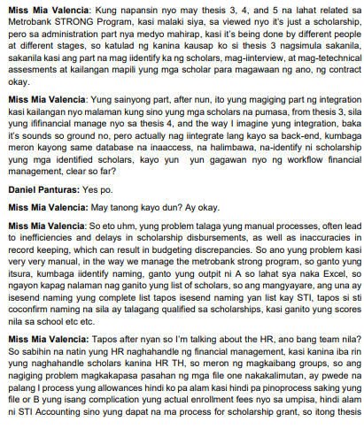**Interviewee: Miss Mia Valencia Representative of Metrobank STRONG Program**

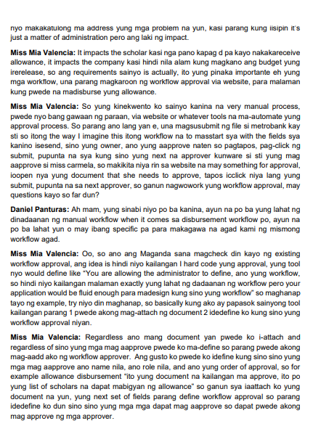

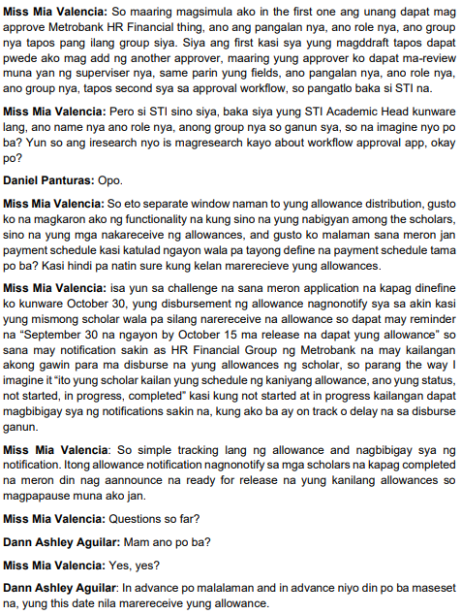

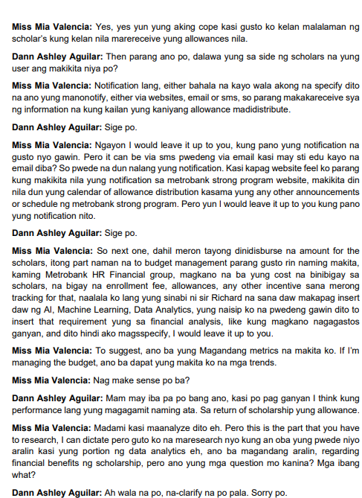

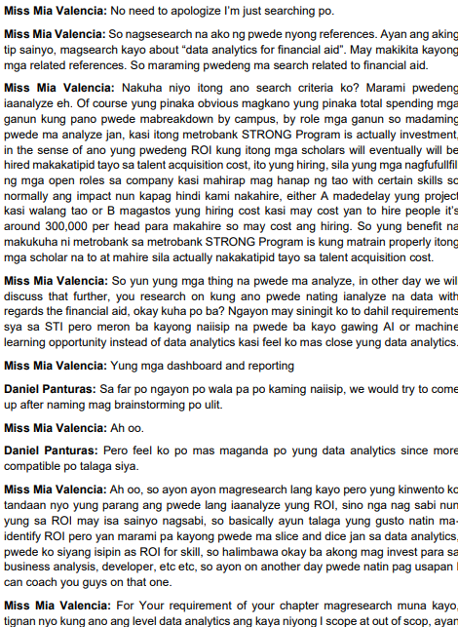



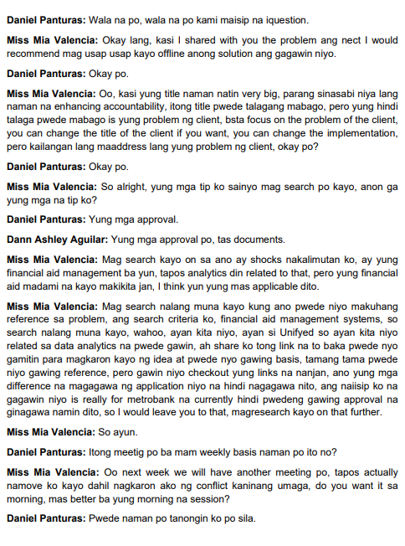 

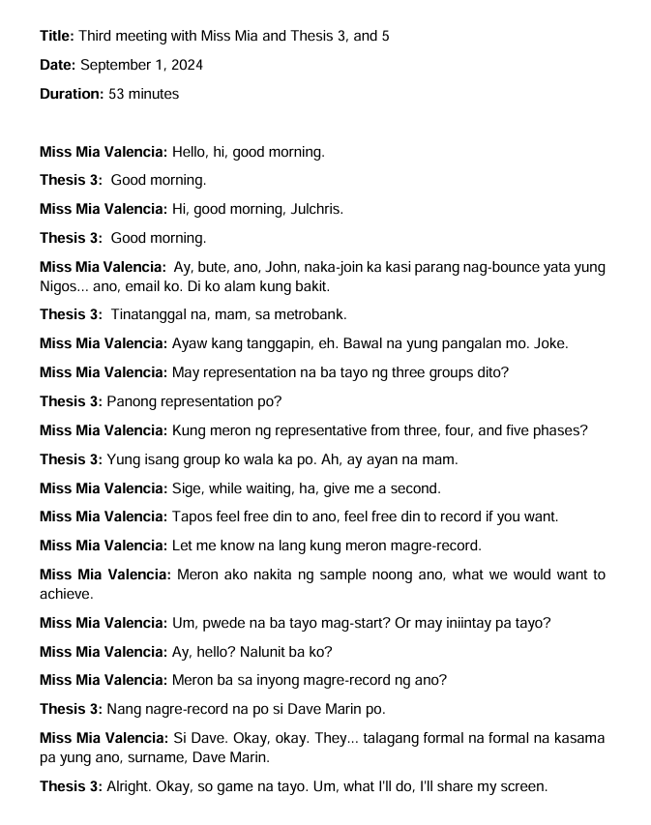

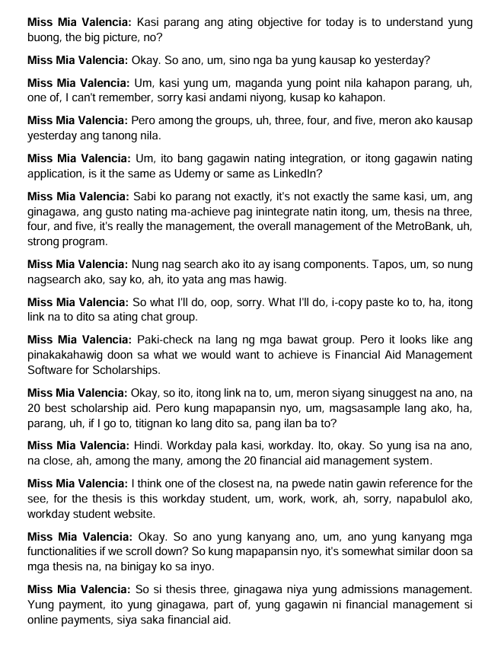



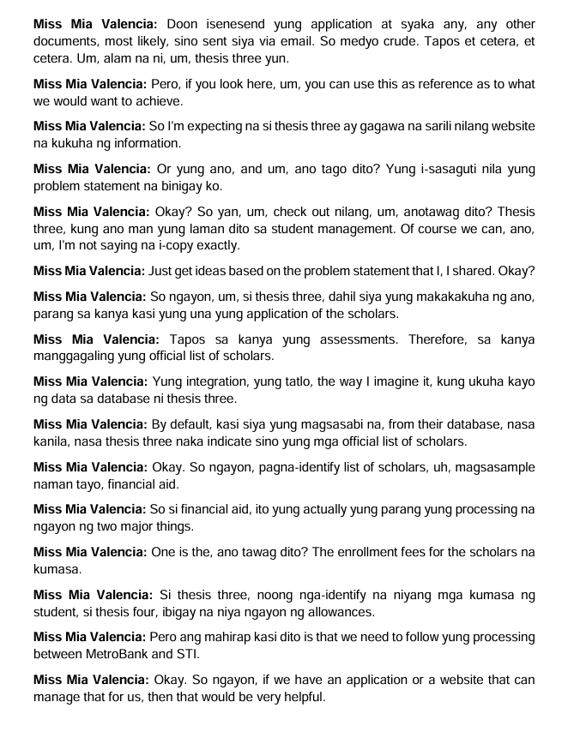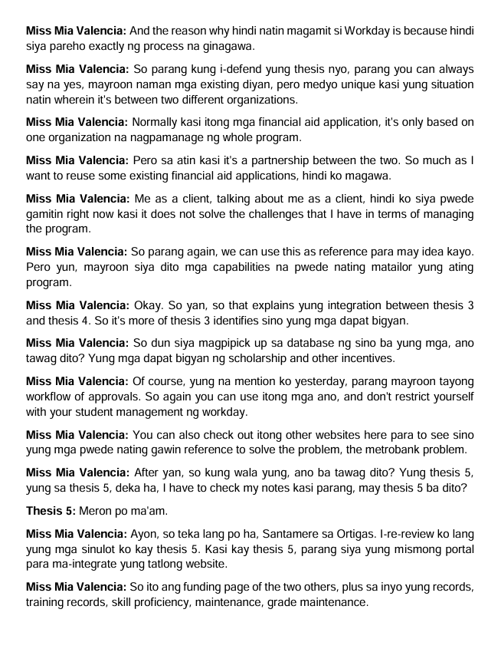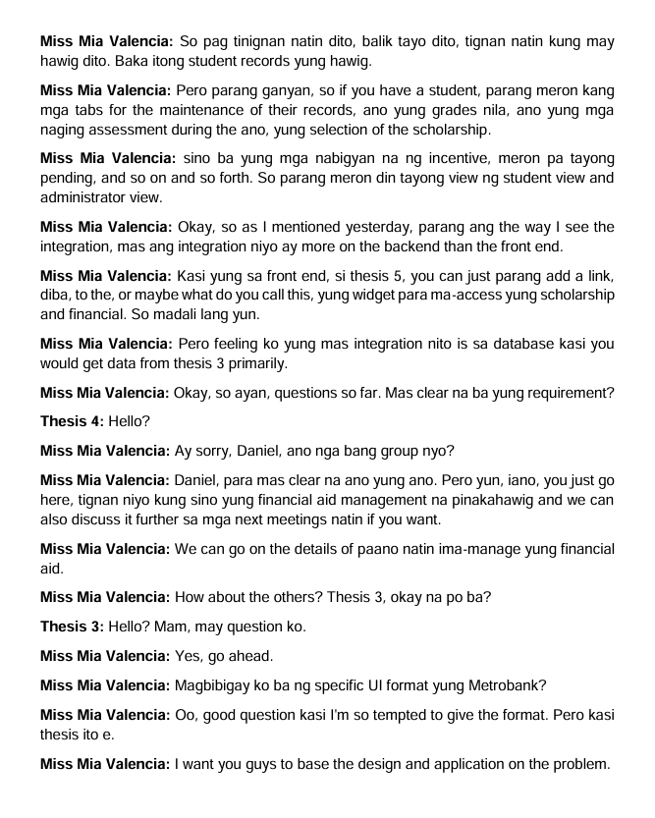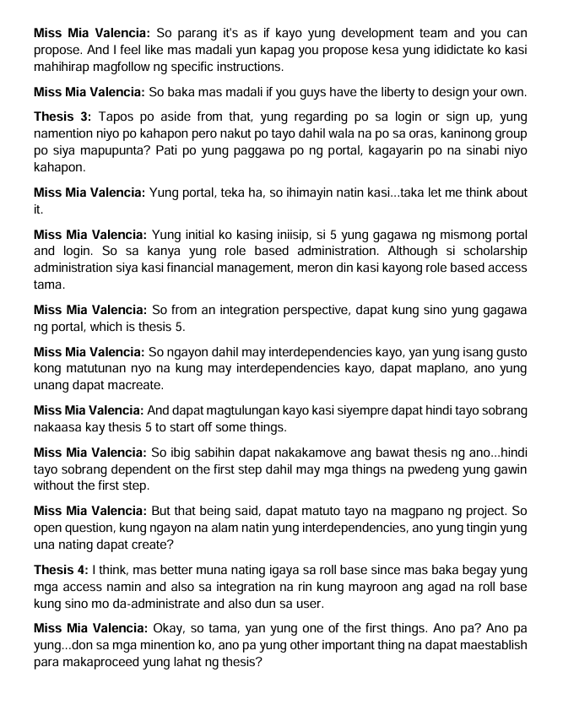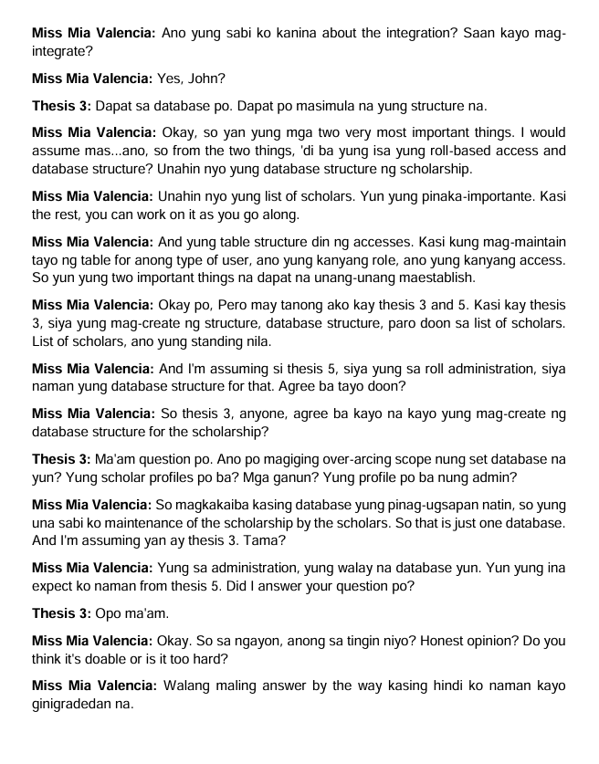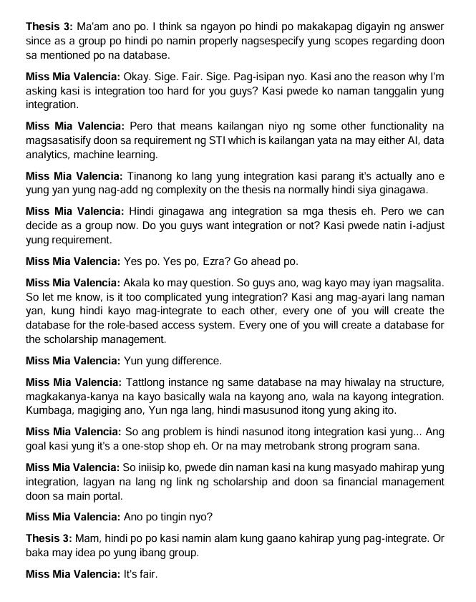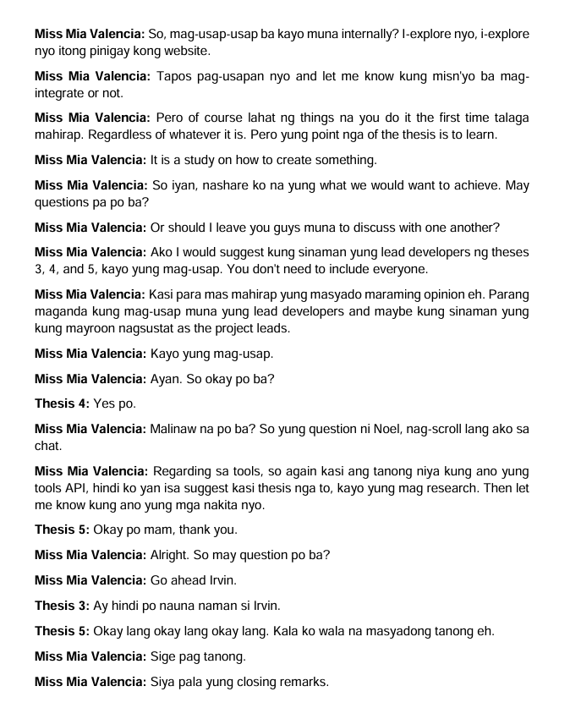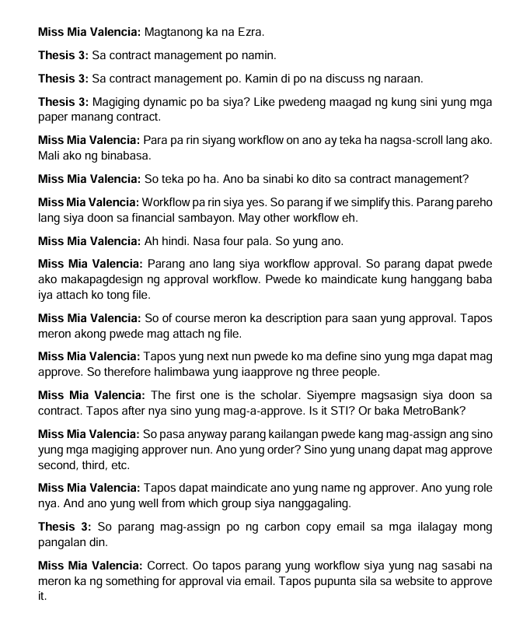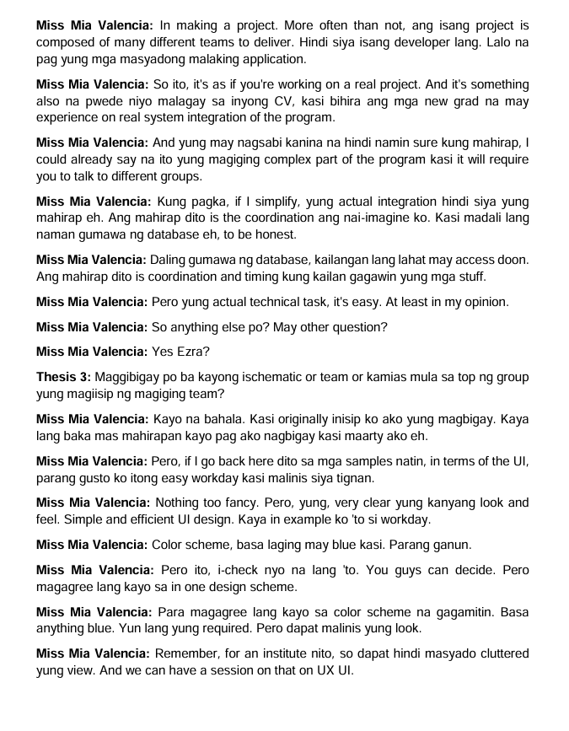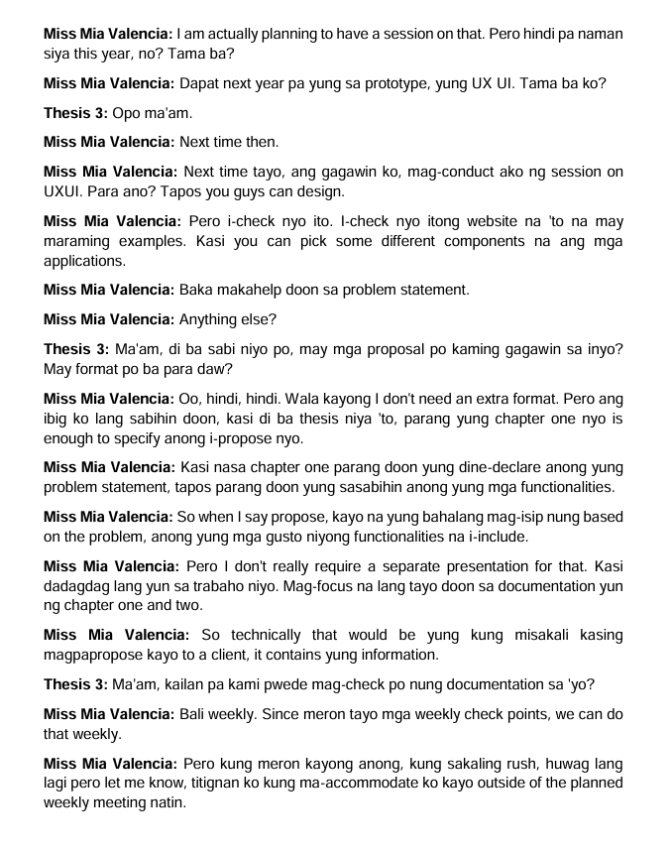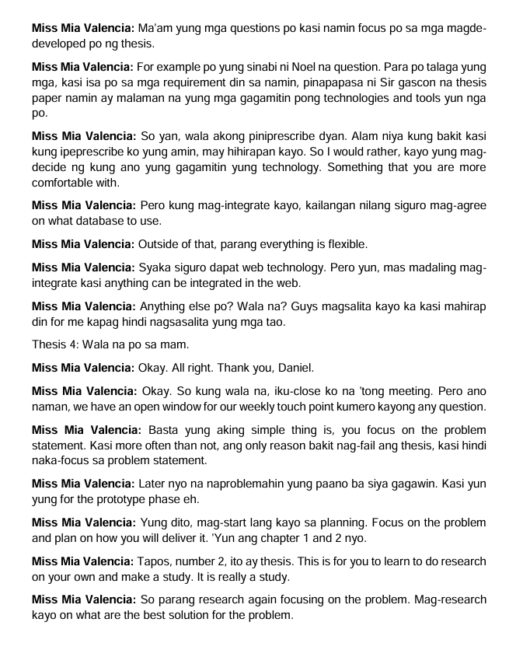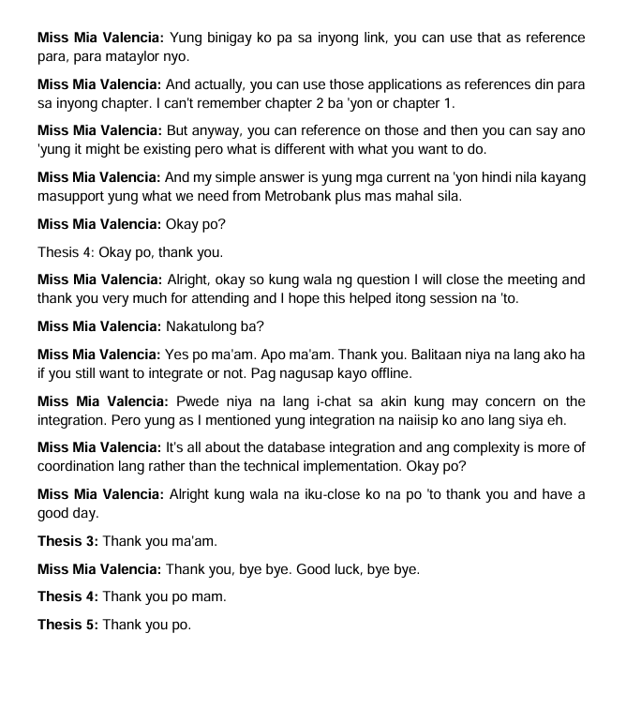

**Meeting with Miss Mia and Miss Ves Revision and Clarification and meeting about the SMART processes about the current process.**

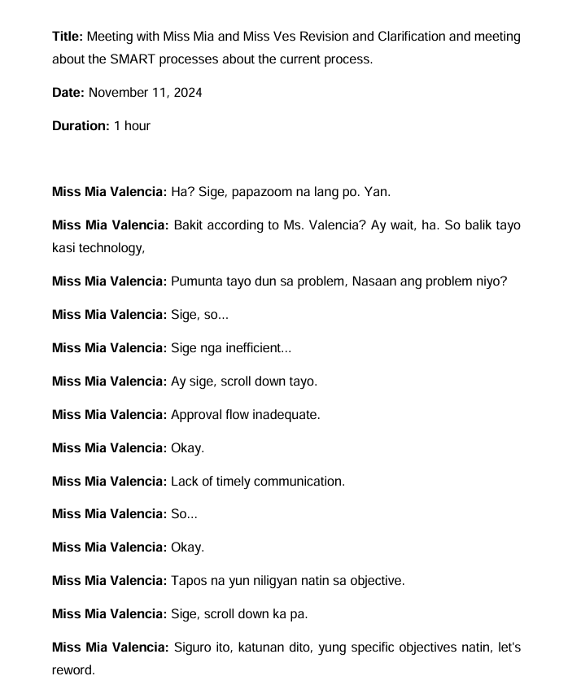

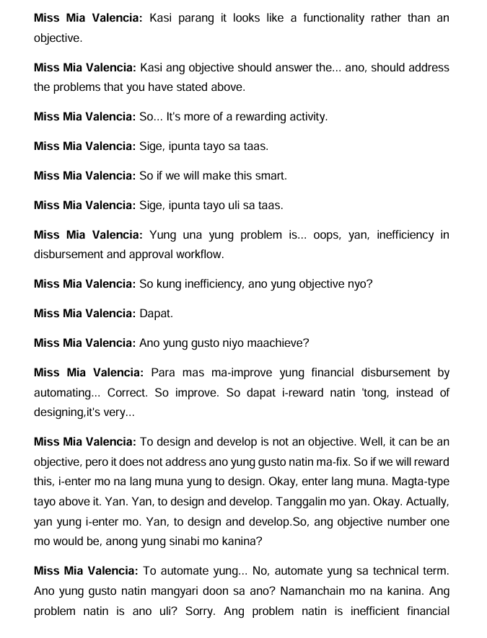

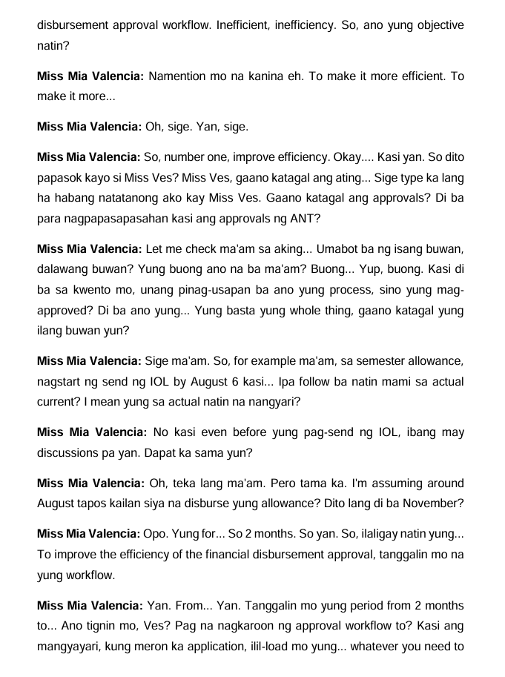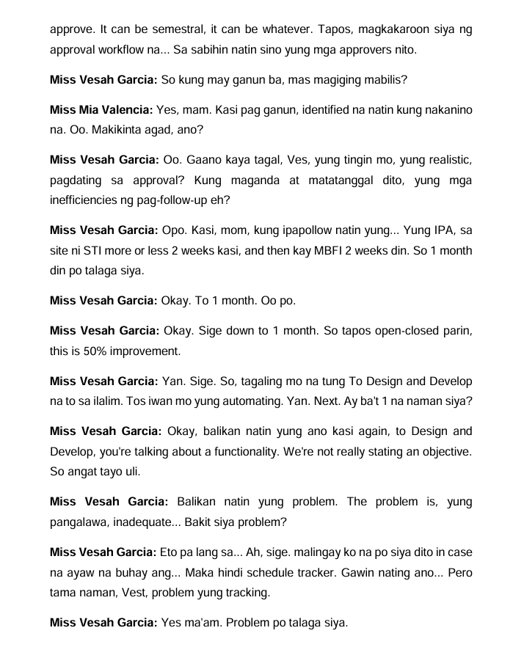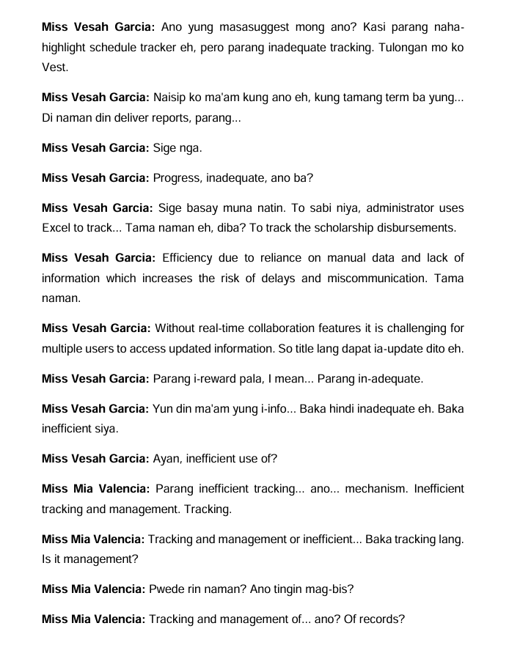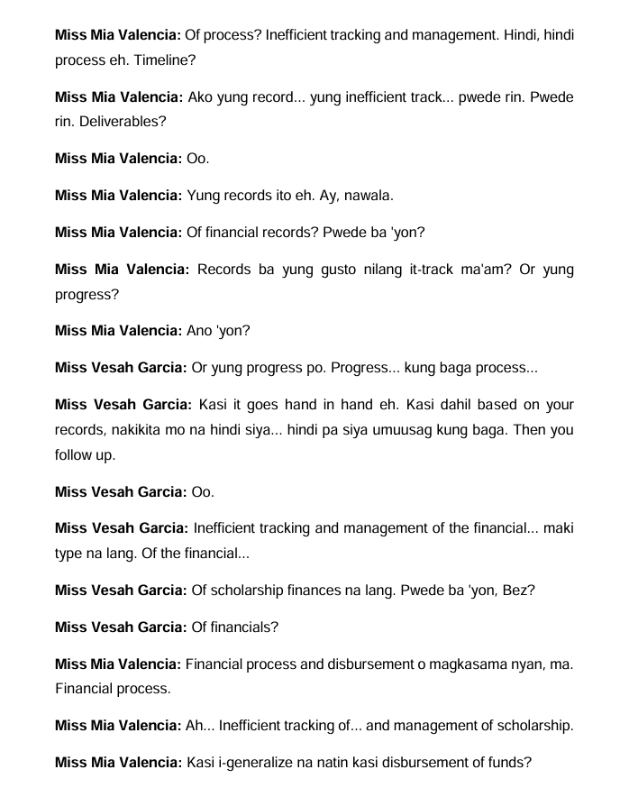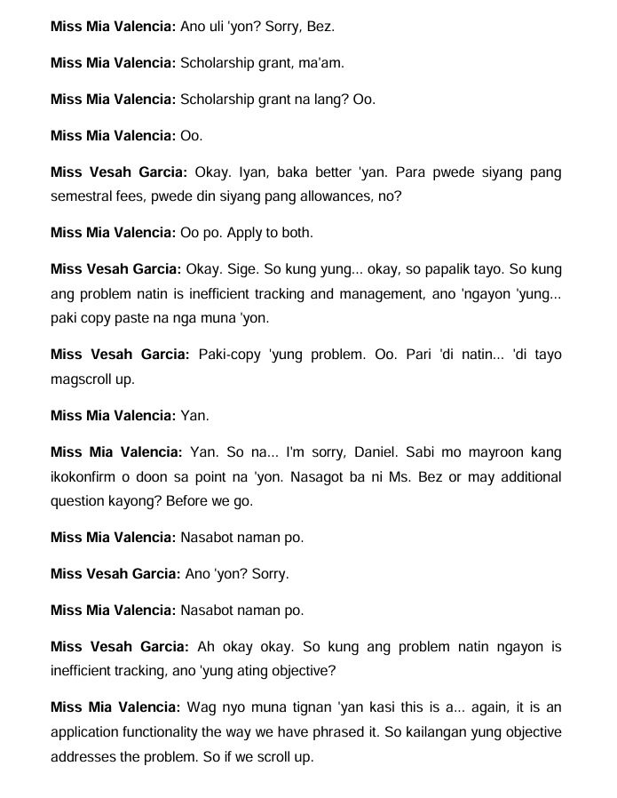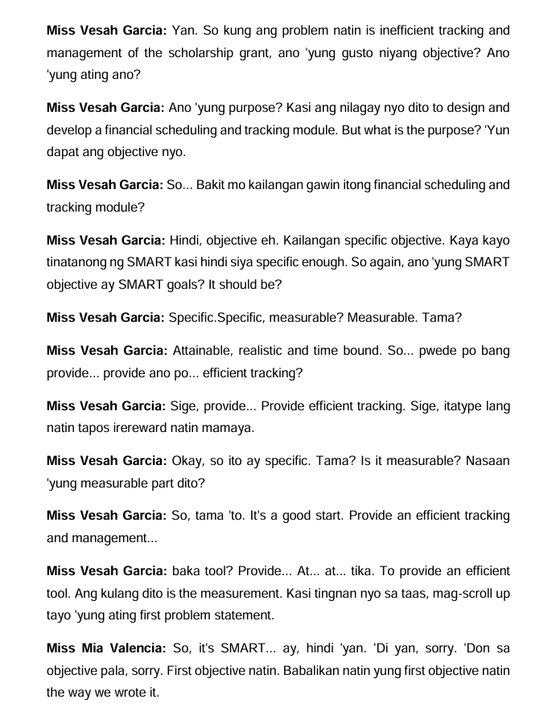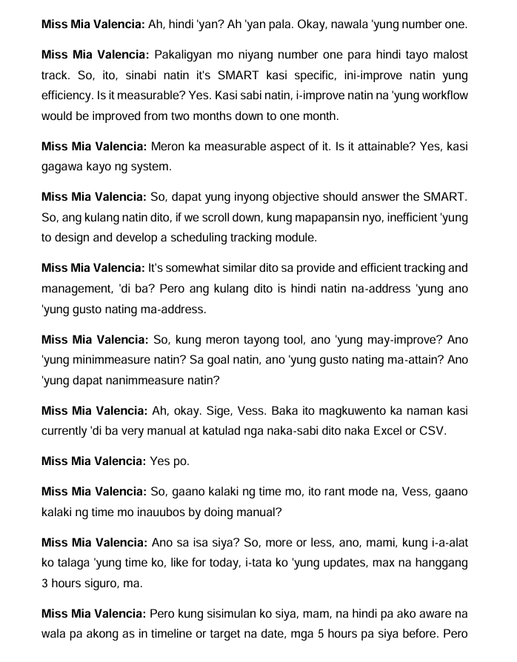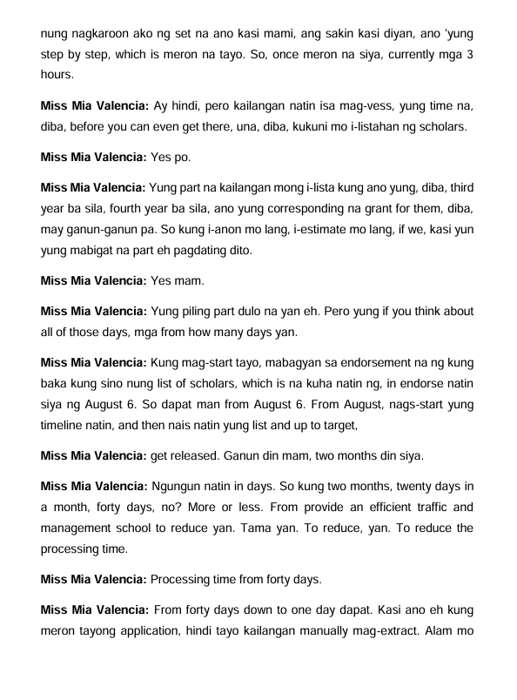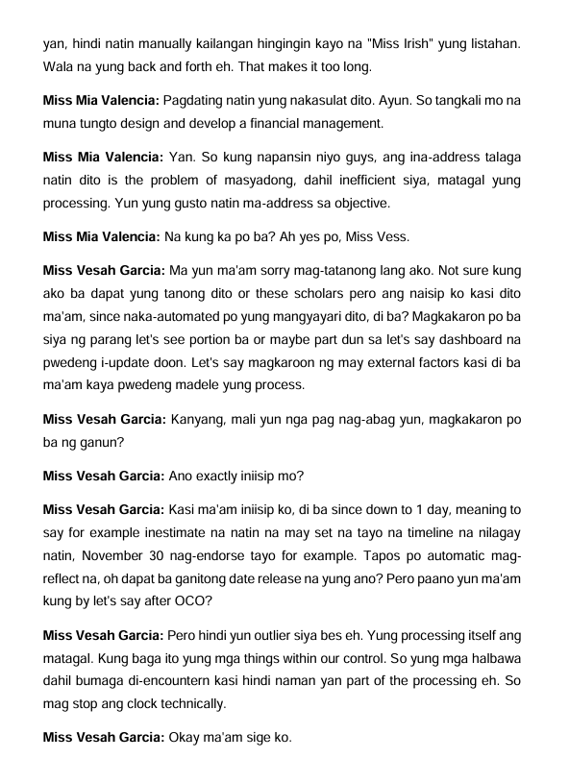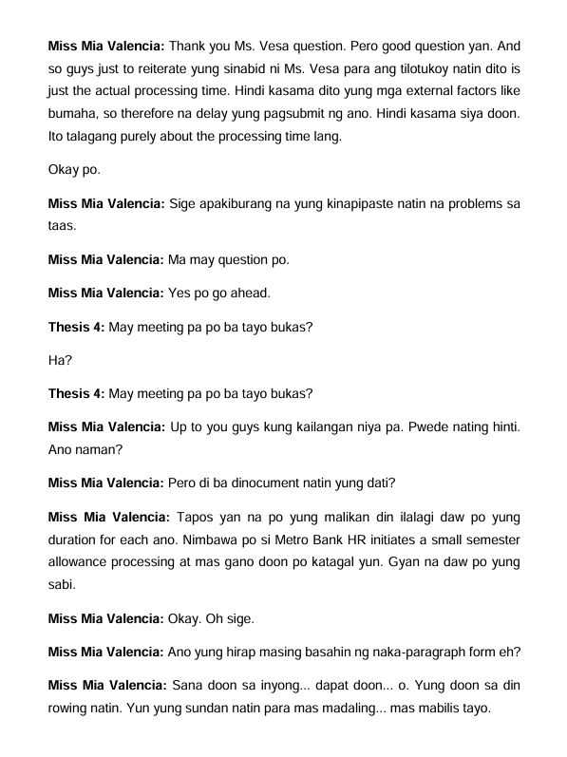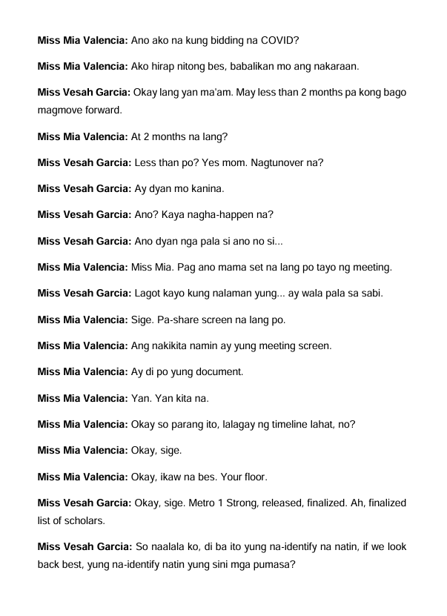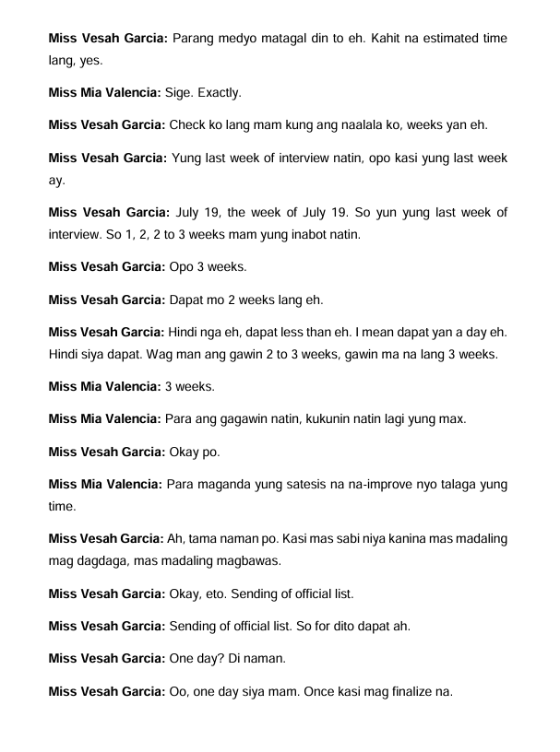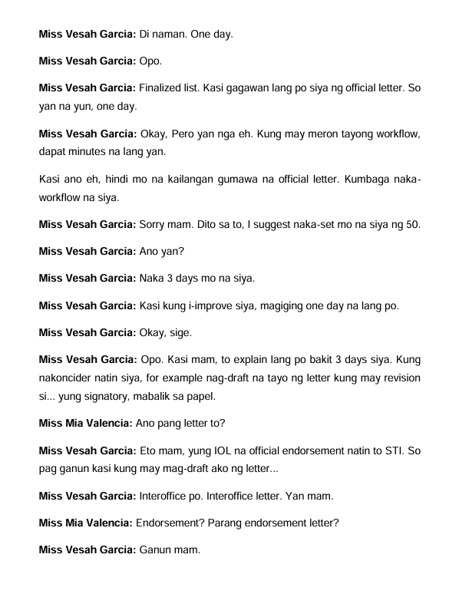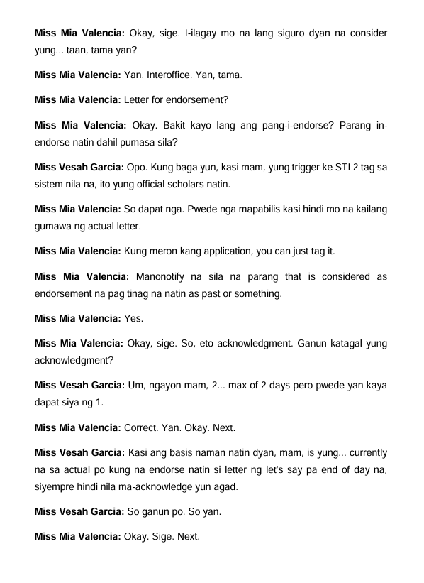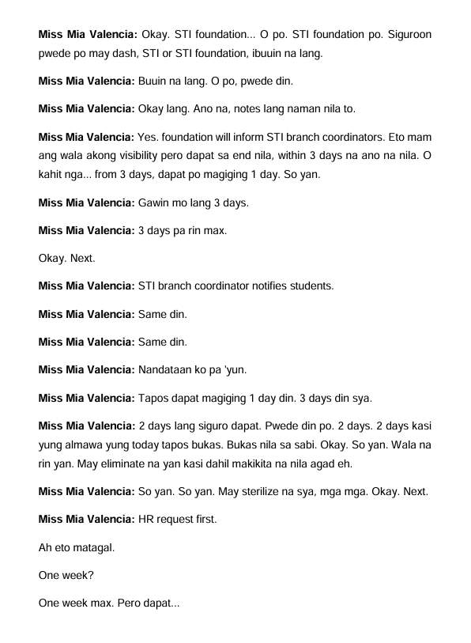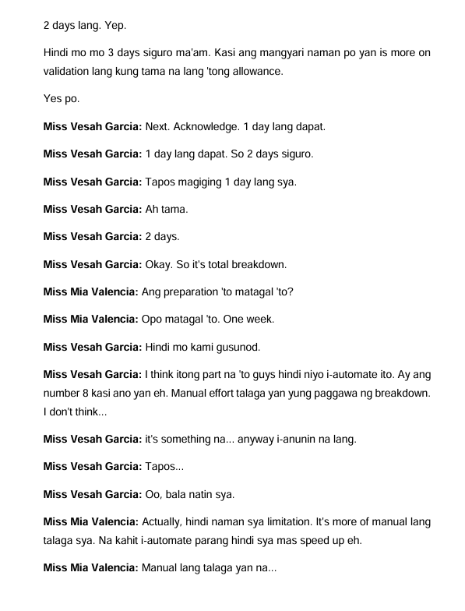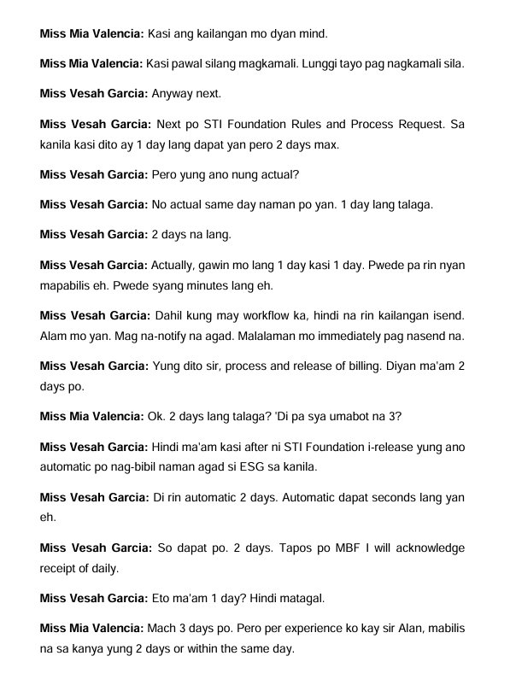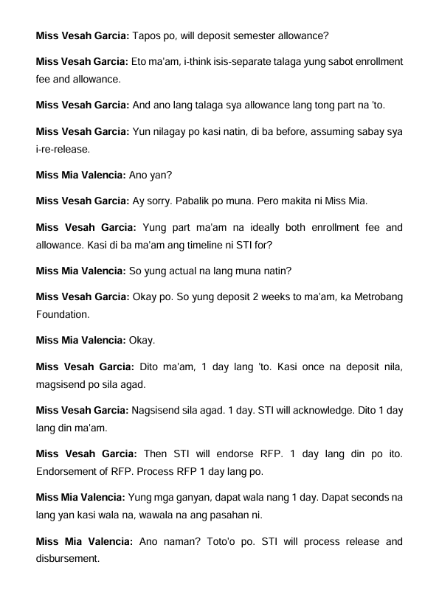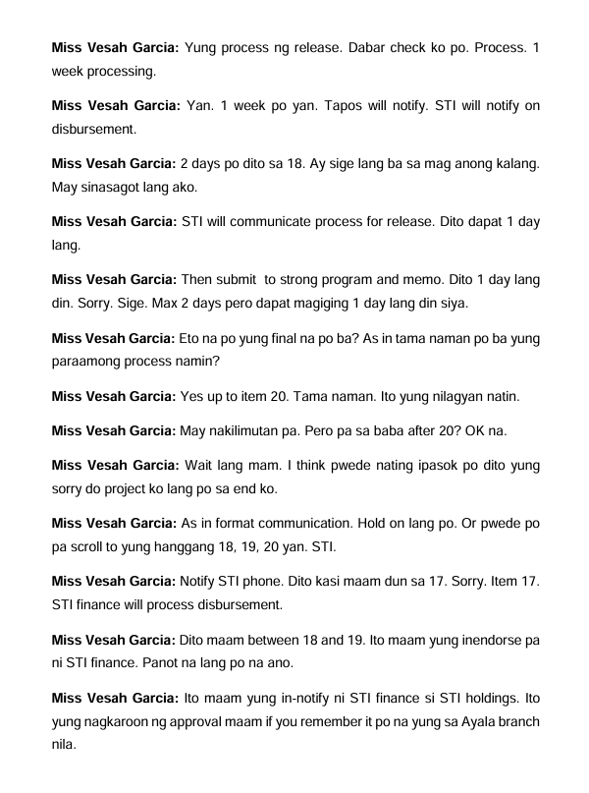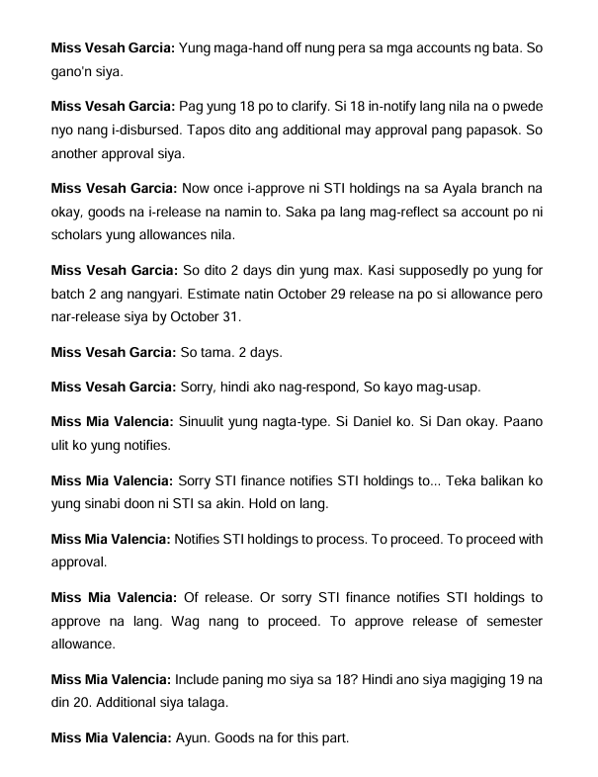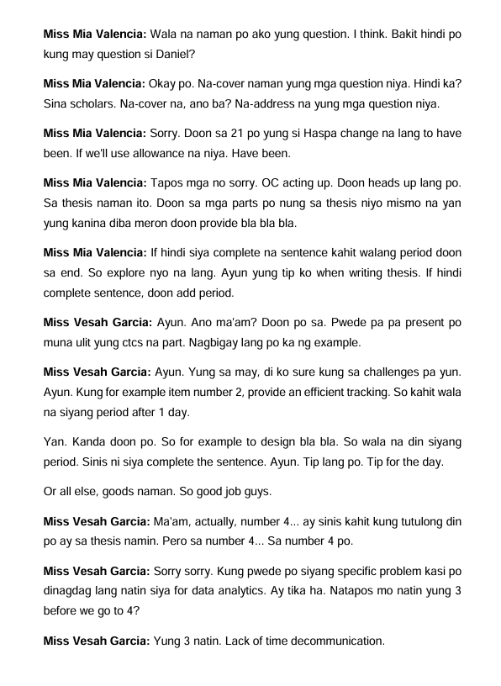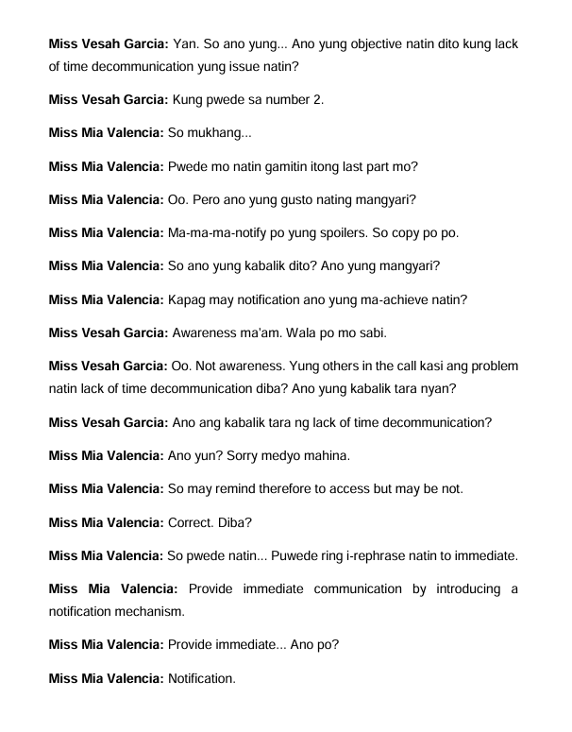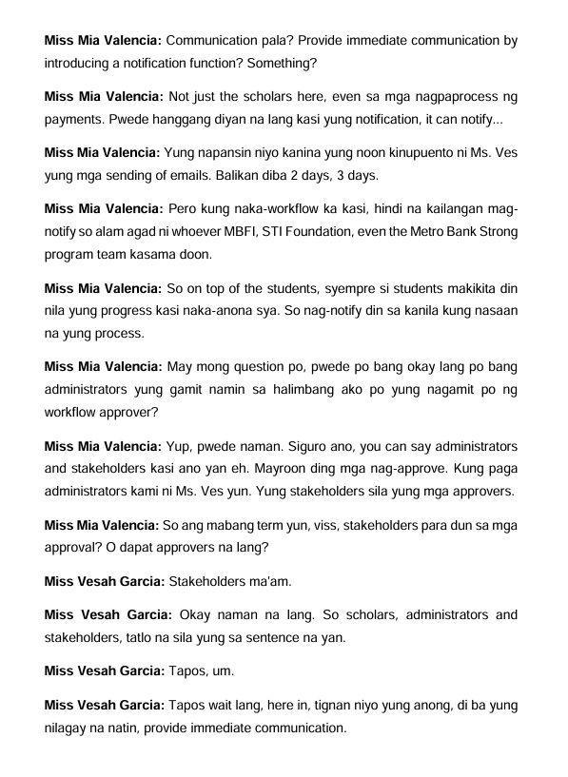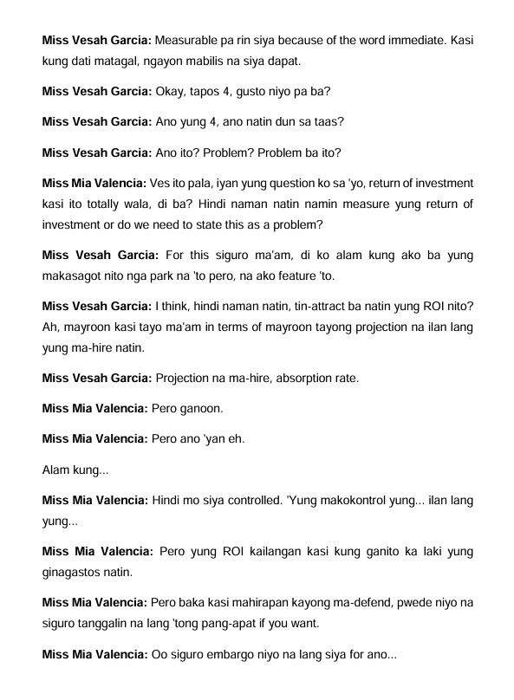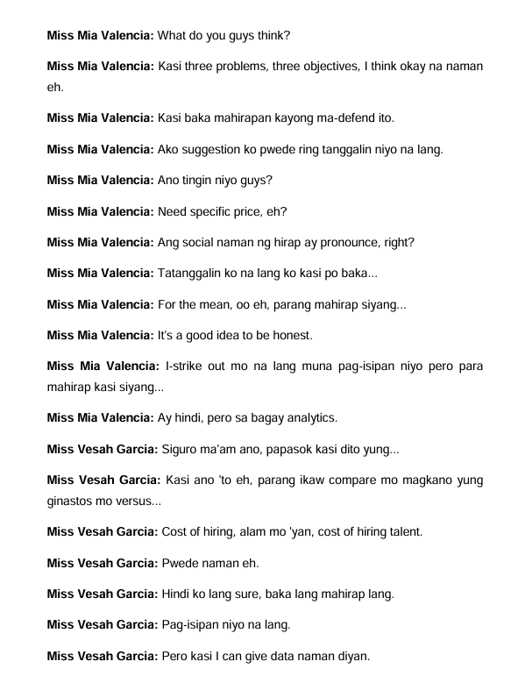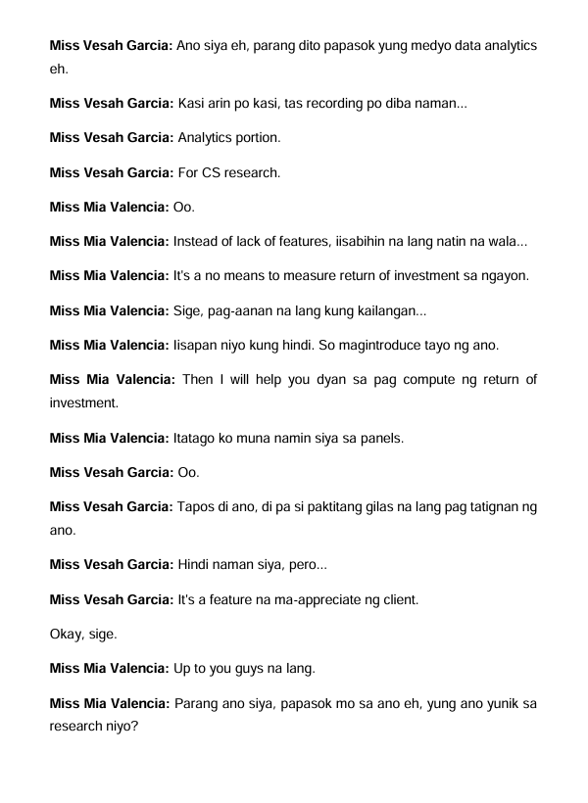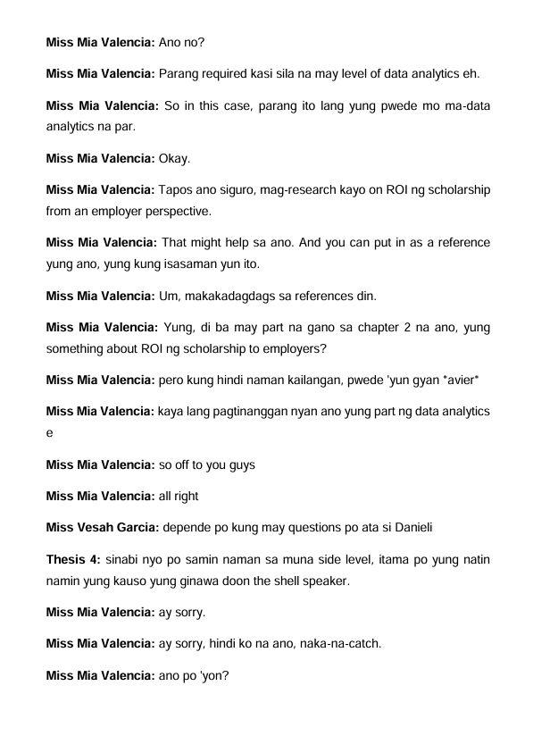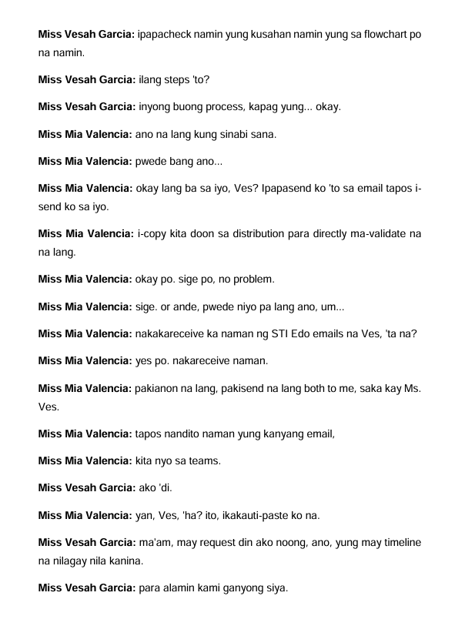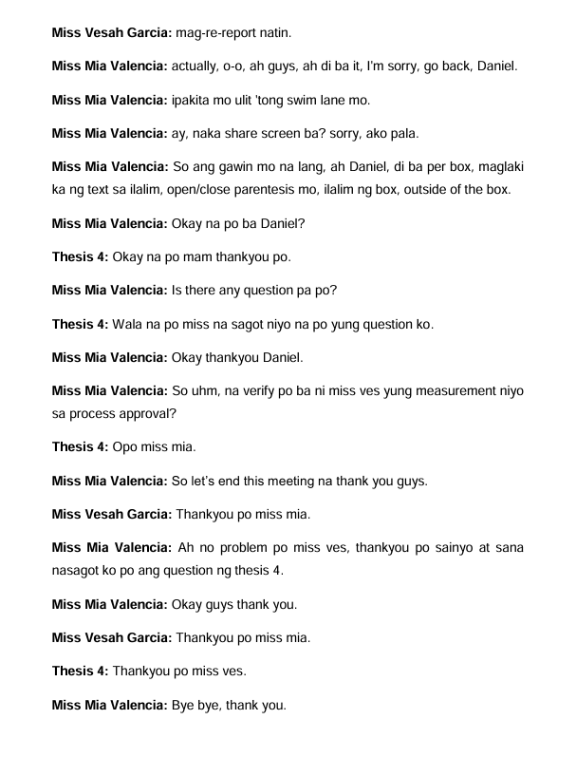

**Meeting with Miss Mia and Miss Ves Introducing the Current Process of Metrobank STRONG Scholarship.**

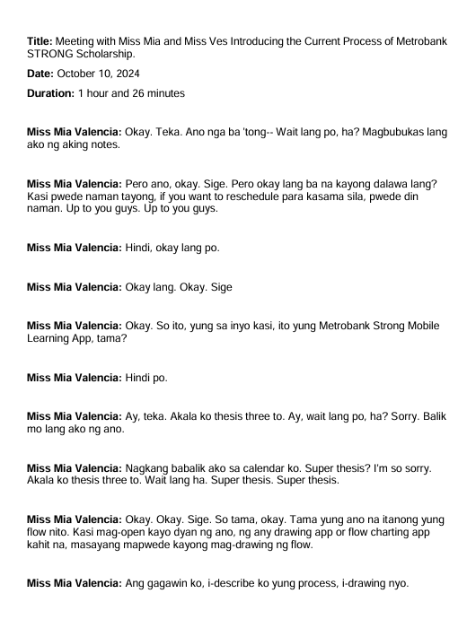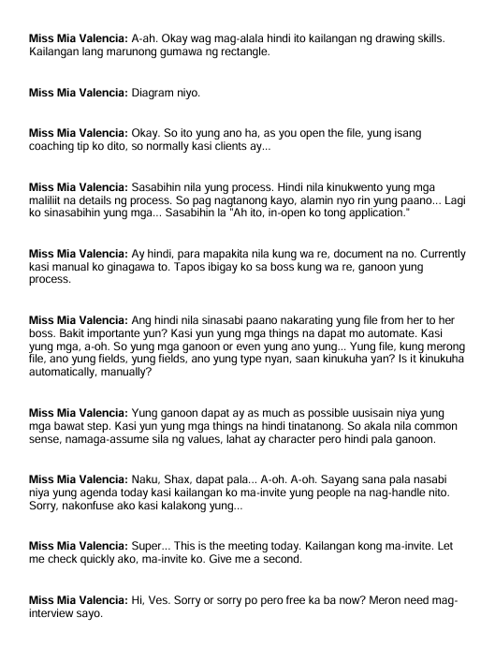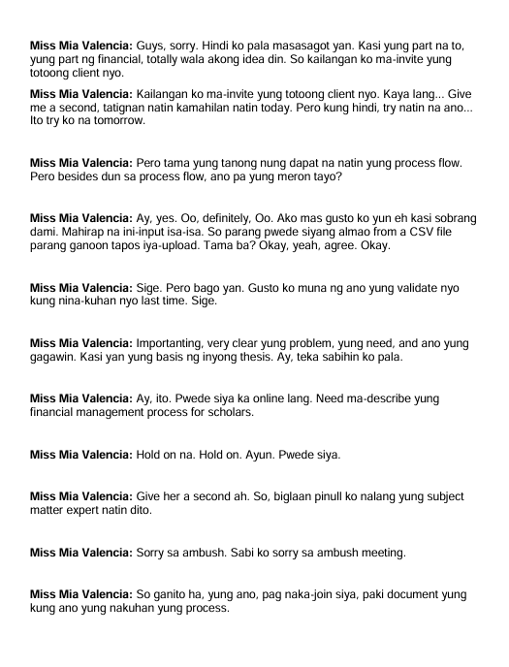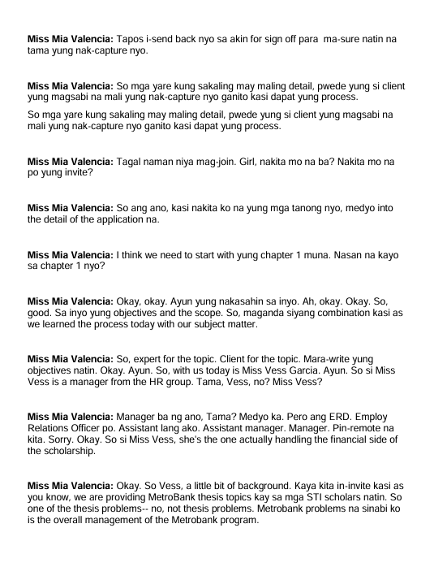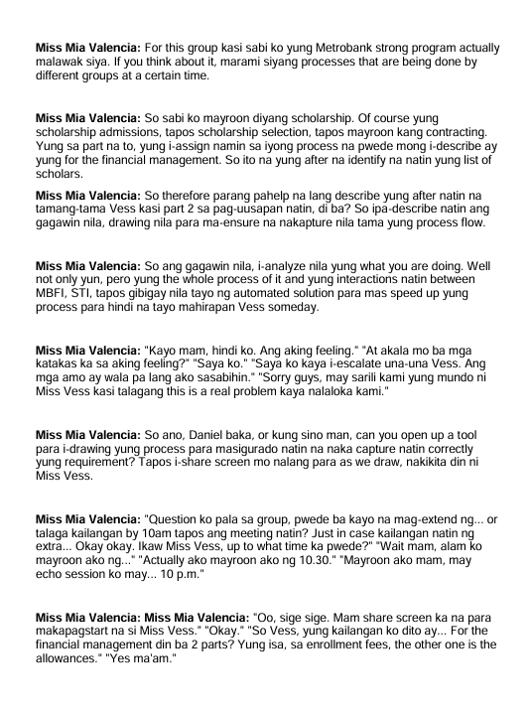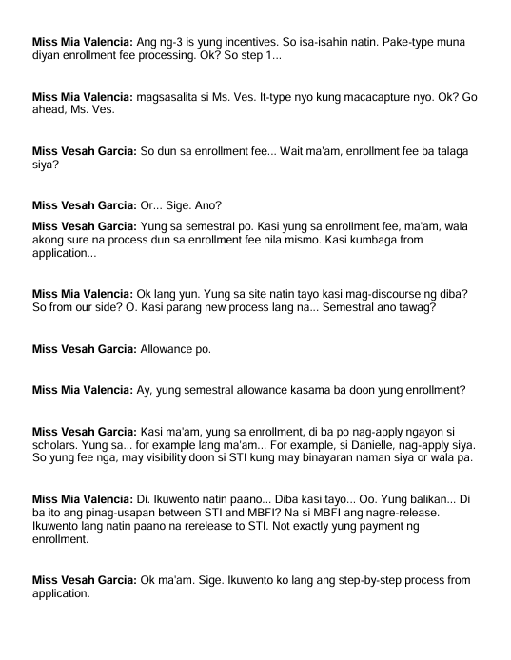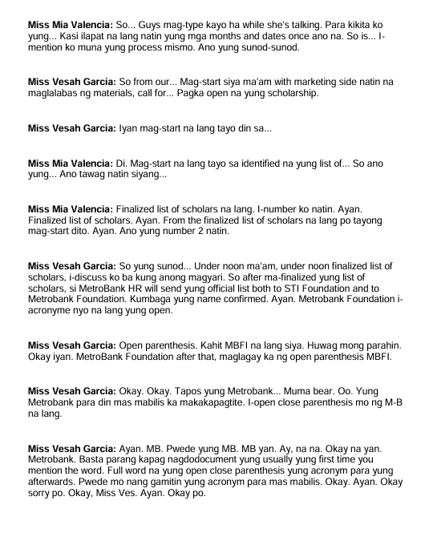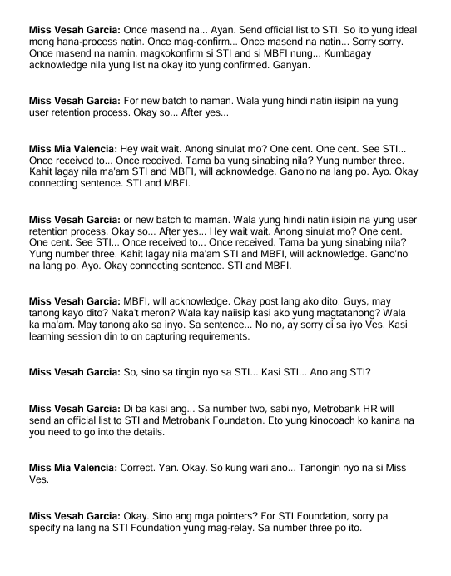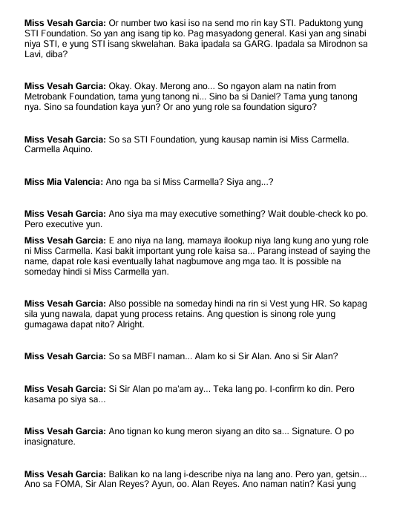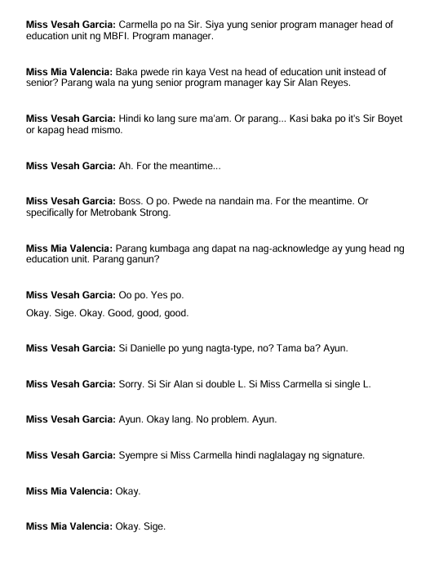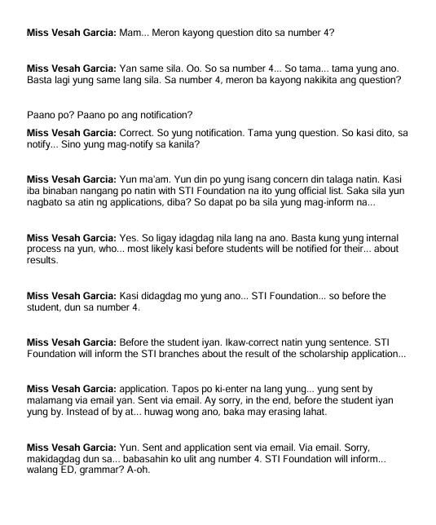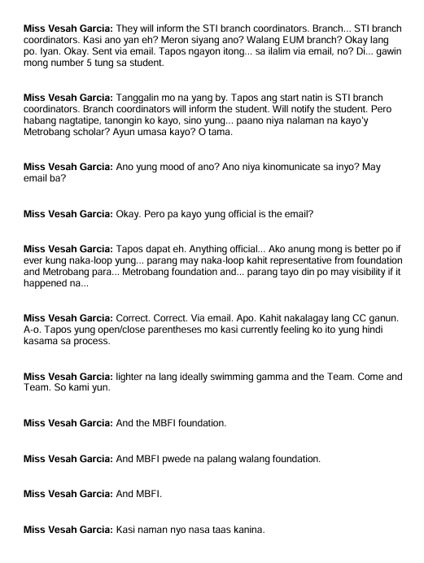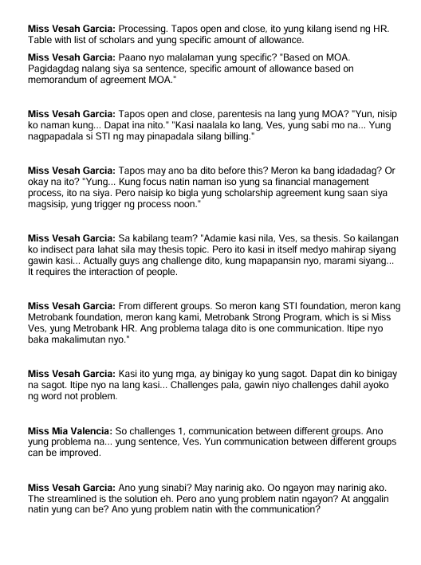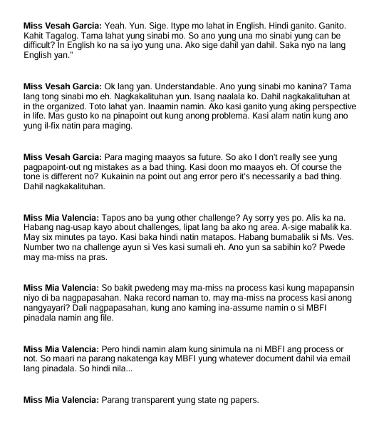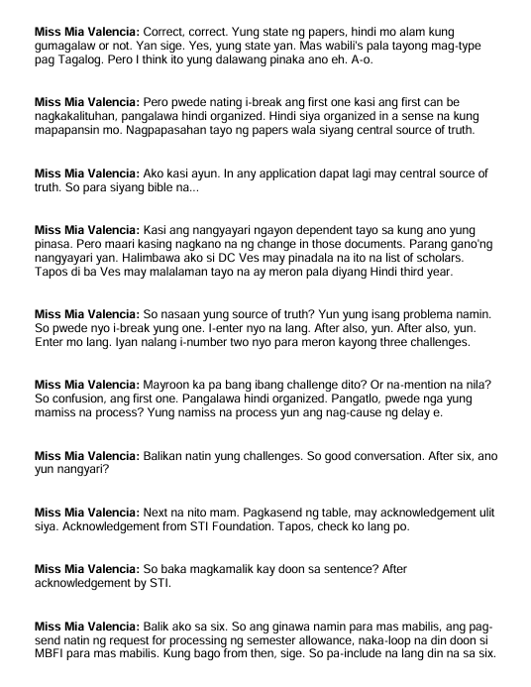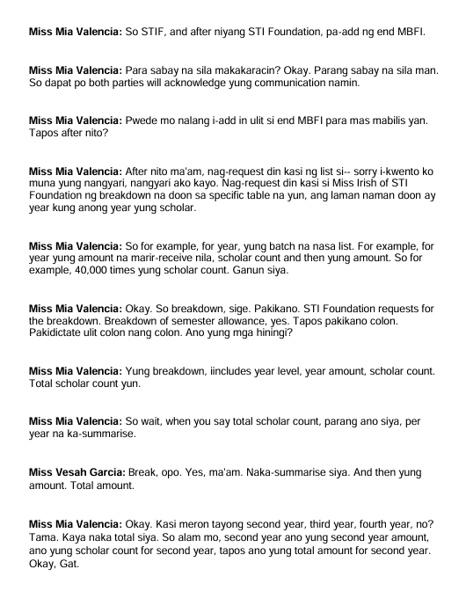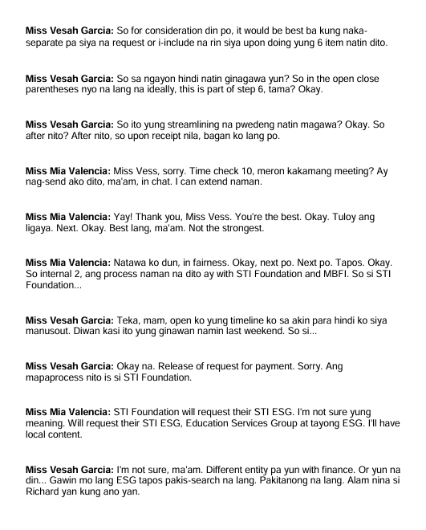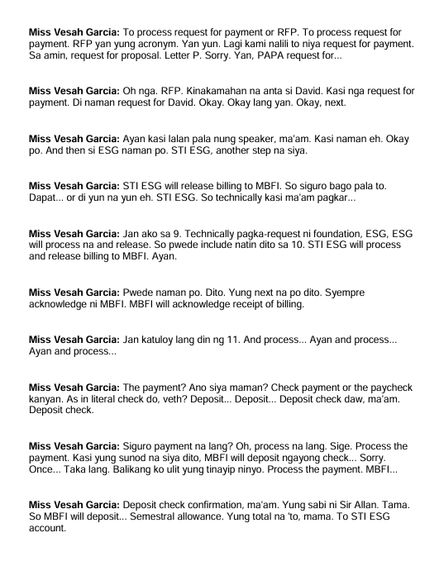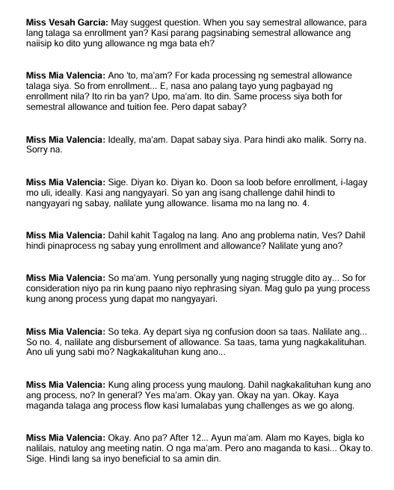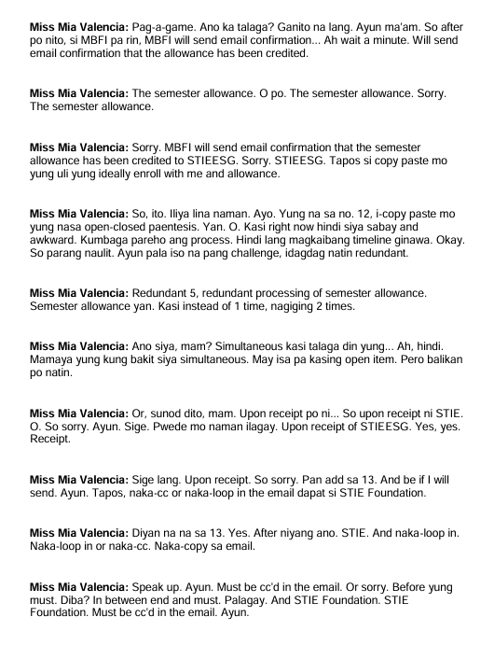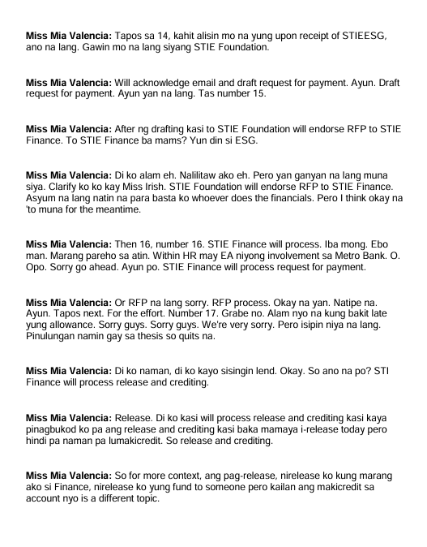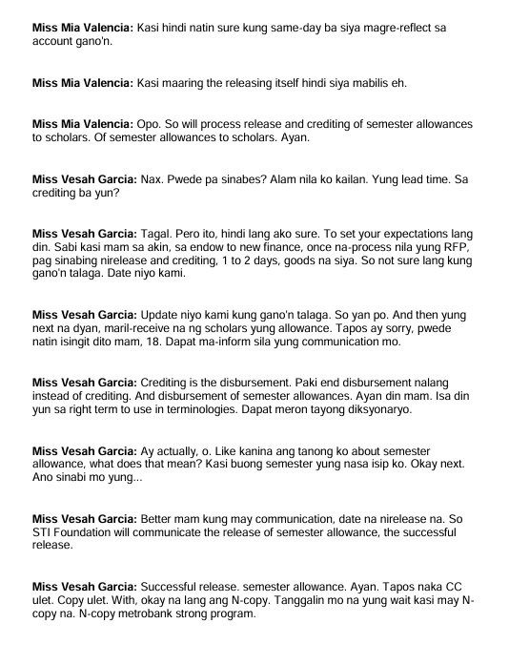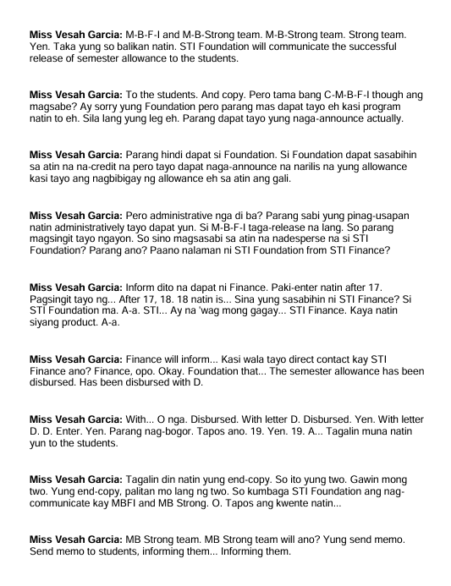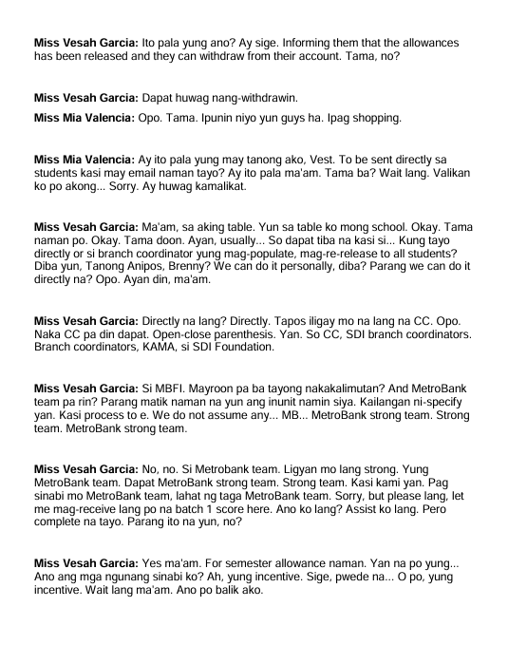

**Appendix B. Proposed Wireframe**

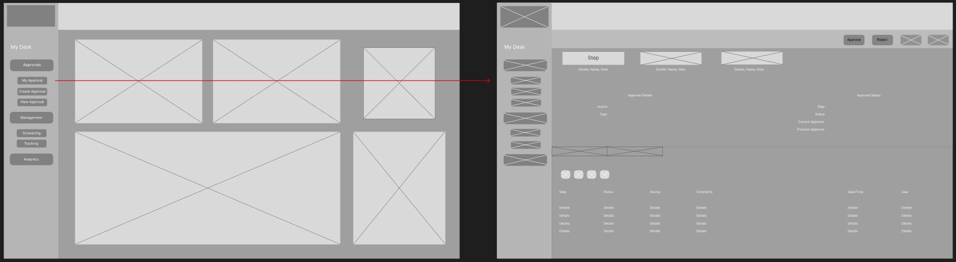

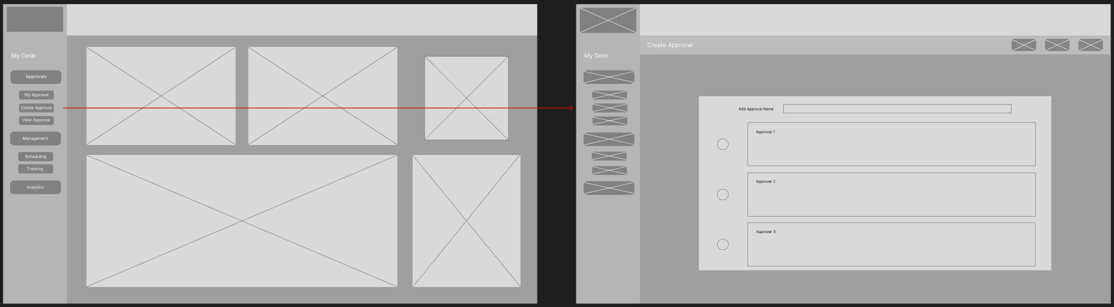

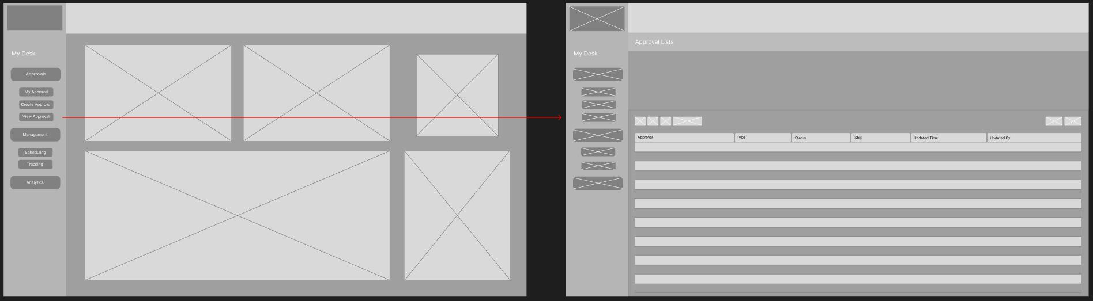

**Approval Workflow Wireframe**

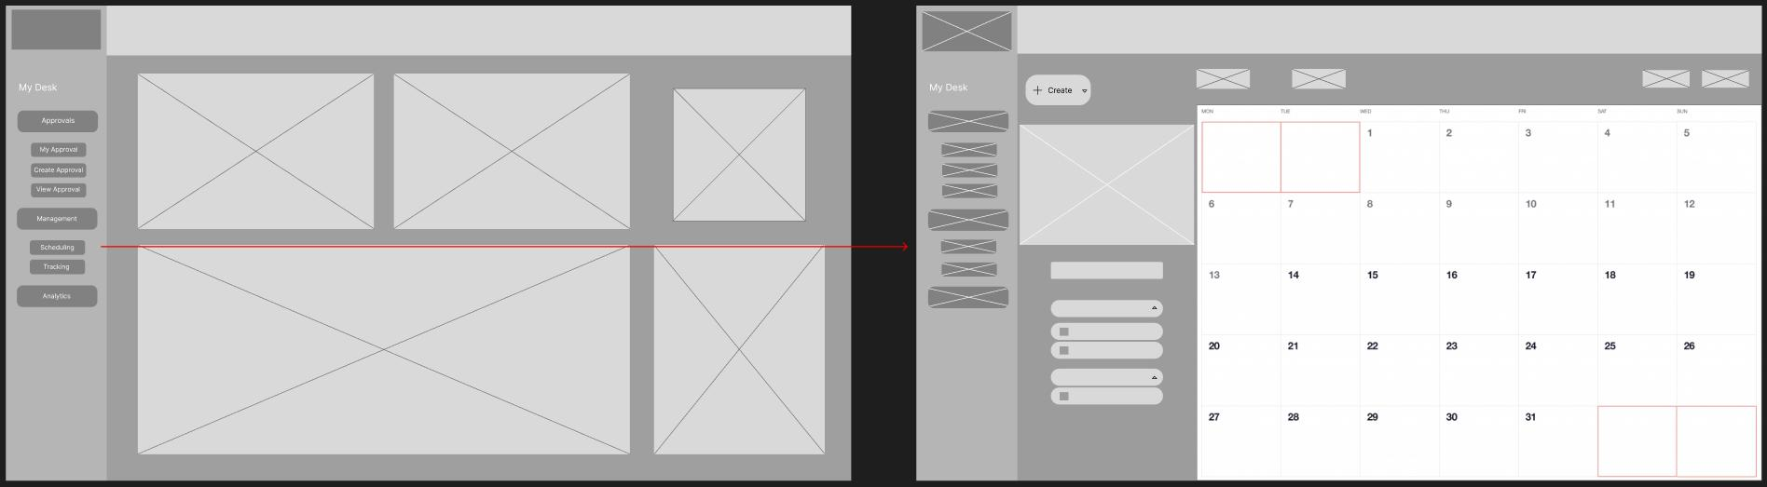

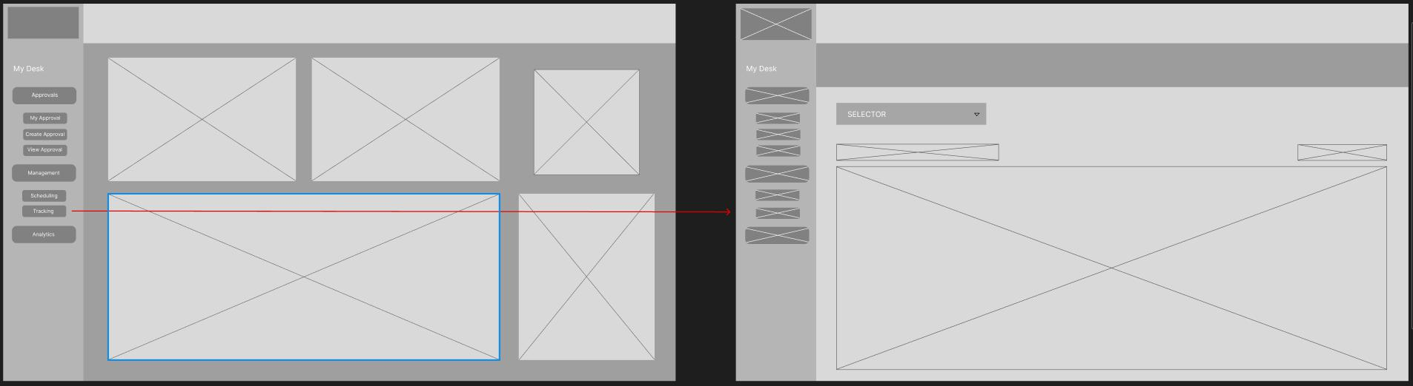**Financial Management Disbursement Module**

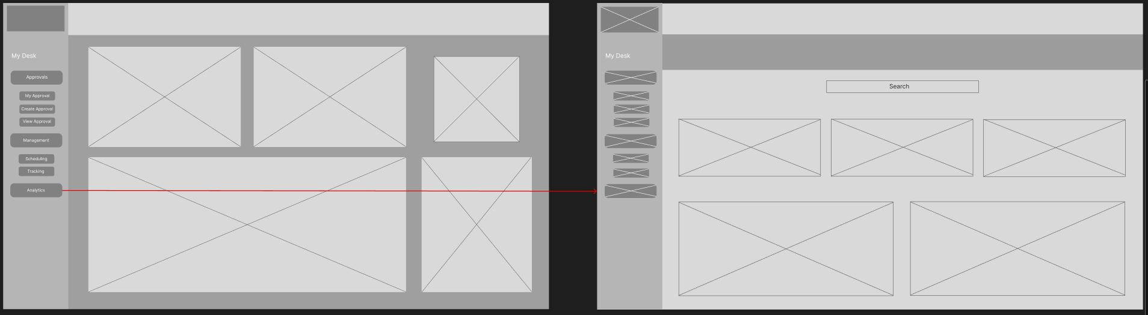

**Data Analytics Wireframe**

**Appendix C. Current System Workflow**

